South Lanarkshire Contextual Safeguarding Approach
Multi-Agency Guidance including Panel Referral Process
2025

Contents | Page
- What is Contextual Safeguarding | 2
- A Contextual Safeguarding Approach for South Lanarkshire | 3
- How is Contextual Safeguarding Implemented | 3
- What is a Contextual Assessment | 4
- Risks Outside the Home | 4
- When to Consider Referral to the Contextual Safeguarding Panel | 6
- What Happens Following Referral to the Contextual Safeguarding Panel | 6
- Purpose of the Contextual Safeguarding Panel Meeting (the Panel) | 7
- Membership of the Panel | 8
- Before the Panel Meeting | 8
- The Panel Meeting | 9
- After The Panel | 10
- Panel Reviews | 10
- Monitoring and Outcomes | 10
- Information Sharing and Confidentiality | 11
- Governance and Accountability | 12
- Learning and Development | 12
- Appendices | 12

Young people from South Lanarkshire involved with the CORRA ASK project provided the following definition of safety:

Safety is feeling secure, protected from harm, and free from fear. Knowing that there are caring individuals who will help if needed, and having trust in the environment and the people around you. It is an internal feeling, developed over time that is affected by signals in the environment and people around you.

- What is Contextual Safeguarding

  - All children and young people have the right to be safeguarded from harm and exploitation as described in national child protection guidance. Traditional approaches to protecting children and young people from harm have focussed on the risk of violence and abuse from inside the home, and there are a wide range of potential risks where the prime cause of harm is outside the family.

  - Contextual Safeguarding is an approach to understanding, and responding to, young people’s experiences of significant harm beyond their families, this can often be referred to as extra-familial harm or risk outside the home (for example harm experienced in communities, social clubs, schools, between peers and in online forums).

  - Contextual safeguarding is an ecological approach which complements the use of the My World Triangle and the concept of resilience, and can add value to various stages of practice including engagement, assessment, planning and intervention as well as prevention. There are principles and tools within this evolving approach which may add depth to understanding and response, particularly in relation to risks and harm young people face beyond the family home. This does not deflect from core child protection steps described in Part 3 of the National Guidance for Child Protection

  - Contextual safeguarding emphasises:
      - exploration of the dynamic between a young person, their family, peers, school context, and areas in their neighbourhood where they spend time, when assessing their needs and developing plans to meet them

      - recognition of the increasing ‘weight of influence’ that peer relationships, and other extra-familial factors, may have during adolescence, and the relevance of this for young people’s experiences of harm and safety

      - a shift in focus towards the contexts in which young people make ‘choices’ or ‘behave’ – so that plans seek to create the conditions in which young people can make safer choices rather than simply focusing on changing young people’s behaviour in persistently harmful contexts

      - the development of interventions that address the social conditions/environmental drivers of extra-familial risk and harm. This can be combined with support to individual young people and families. Such an approach can create safety for those identified as being at risk of significant harm in extra-familial contexts alongside broader populations of young people who spend time in those contexts”
(National Guidance for Child Protection in Scotland (2021 - Updated 2023)

  - The principles of Contextual Safeguarding are:
    - Collaborative: Collaborating with professionals, children and young people, families and communities to inform decisions about safety.
    - Ecological: Considering the links between the spaces where young people experience harm and how these are shaped by inequalities.
    - Rights-based: Rooted in children’s and human rights.
    - Strengths-based: Building on the strengths of individuals and communities to achieve change.
    - Evidence-informed: Producing research that is grounded in the reality of how life happens. Proposing solutions informed by lived experience.

- A Contextual Safeguarding Approach for South Lanarkshire

  - Contextual Safeguarding is included in child protection guidance and should also be a part of a GIRFEC approach.

  - Aligning contextual safeguarding with South Lanarkshire GIRFEC approach will be developed as we continue to increase our understanding and confidence in applying this approach (further practice developments will be reflected in relevant documentation).

  - This guidance has been developed from a child protection perspective for a multi-agency operational and strategic audience. As our approach to contextual safeguarding develops consideration should be given to developing specific guidance for CPC partners, practitioners and wider community.

  - A starting point for South Lanarkshire is to embed contextual safeguarding within our child protection process where the threshold for significant harm is met. This guidance will outline current plans and will be reviewed and updated as our model evolves.

  - To provide additionality to our child protection process in relation to significant risks outside the home a multi-agency contextual safeguarding panel is being established.

  - Development of our approach will be informed through engagement with young leaders and peer researchers supporting the CORRA funded ASK project.

  - Contextual Safeguarding concerns do not just affect under 18’s. In South Lanarkshire development of the GIRFE (Getting It Right for Everyone) approach is in its infancy and further details as to the intersectionality with contextual safeguarding will be included in future updates of this guidance.

- How contextual safeguarding is implemented

  - Contextual Safeguarding can be implemented at two levels:
    - At level 1 professionals and organisations draw extra-familial contexts into their direct work with children and families (For example, if a young person is stabbed, sexually assaulted, or groomed into drug dealing in an extra-familial context)

    - At level 2 professionals and broader organisations, develop practices, systems and structures for identifying, assessing and intervening with contexts and groups in which young people are at risk of significant harm. An example is assessment of a young person’s peer group if abuse has occurred in that context or protection could be sourced there. A peer assessment framework can support exploration of a group’s dynamic, the ‘guardianship capacity’ around the group, and the contexts in which the group spends their time,

  - This is a radical shift in practice, requiring child protection professionals to not only acknowledge the relationship of contexts to individuals but actively take steps to change those contexts. Such an approach can help practitioners to identify the partners needed to increase safety in peer groups, schools, and public places, also to work with new partners to source collective and contextual solutions.

  - Levels 1 and 2 run in parallel to and inform each other.

  - Where the threshold for significant harm is met assessment and planning with regards to extrafamilial risks and harms should be included in the child protection process. This means that a contextual assessment should be undertaken by the social worker when completing the CP1.

  - Where the child protection planning meeting chair requires additionality for their multi-agency action plan to safely manage the risks and harms outside the home a referral can be made to the contextual safeguarding panel to consider what could be done differently to disrupt the extrafamilial risk and harms.

  - Referrals to the contextual safeguarding panel can be made regarding either an individual child/young person or a group or children/young people (for example in relation to sexual and criminal exploitation, online exploitation, or peer-on-peer abuse), and in relation to a place or context where young people are at risk of significant harm (examples of this could be a park, a street, public transport, online etc).

- What is a contextual assessment

  - To help build a picture of the social conditions of harm contextual assessments focus on three key aspects:
    - Young people’s views and experiences of safety and harm
    - Parental and community guardianship in the context
    - Resources, partner information, structural and environmental factors

  - Hearing from young people, guardians (parent/carers, partners, professionals, residents, businesses) and learning about the wider environment (policy, resources, structure, environment, systems) will offer a view of the interplay of contextual dynamics causing harm, and the possibilities for strengthening safety.

  - A contextual assessment will help with identifying what needs to be targeted and how.

- Risks outside the home

  - Where the risk of harm is significant, an Inter-Agency Referral Discussion (IRD) should be initiated to discuss the concerns for the individual child/young person (refer to Inter-Agency Referral Discussion (IRD) Pan Lanarkshire Multi Agency guidance 2022).

  - Child Protection procedures should be initiated via an IRD upon any report of exploitation relating to a child under the age of 18 years.

  - Where an IRD considers that child protection investigation and planning is required in respect of risks outside the home a contextual assessment should be undertaken as part of child protection assessment and planning (CP1) for consideration at the child protection planning meeting (CPPM).

    - Child protection procedures https://intranet.southlanarkshire.gov.uk/downloads/file/4127/south_lanarkshire_multi-agency_child_protection_procedures_2023
For children over the age of 16 years old Adult Support and Protection (ASP) processes should also be considered and where appropriate followed:
- Adult Support and Protection procedures https://intranet.southlanarkshire.gov.uk/download/downloads/id/7461/adult_support_and_protection_procedures.pdf
Practitioners should pay particular attention to the needs and risks experienced by young people in transition from youth to adulthood, who may be more vulnerable to harm than others. This means that situations may arise, particularly for 16- and 17-year-old young people, where engagement from services for both children and adults is appropriate.
The Care and Risk Management (CARM) process should be considered for children/young people who pose a risk of serious harm to others because of unmet needs and behaviours that indicate either violent conduct or involvement in sexually harmful behaviour that poses a risk of serious harm to others.
(Link to be added to updated CARM procedures when these are finalised)

  - The aim of contextual assessment and planning is to bring a contextual lens to casework and highlights the child or young person’s voice. It does not replace child protection processes and should be undertaken as part of child protection procedures.

  - As part of the contextual assessment the lead social worker(s) can complete the safety mapping tool (appendix D) alongside the child/young person. Completion of this tool will provide information as to how safe or at risk the child/young person feels and supports understanding of the spaces (including online) where they spend their time. This mapping informs a young person’s plan, for example if a young person needs to travel through an area where they feel unsafe to meet their worker or attend school, the safety plan could include finding a safe person for them in that area.

  - Where the safeguarding concern relates to a peer group it may be appropriate for the social worker and young person to complete the peer group map (appendix E). This tool can support understanding of the scope of peer networks, with a focus understanding the problems, identifying gaps in information and planning for managing the issues which emerge. Peer group mapping should not be used as a surveillance or monitoring tool.

  - The social worker may want to use the peer group assessment tool (appendix F) to inform planning. This tool can support assessment of the strengths and harm within peer group dynamics.

  - With regards to concerns about a place or context the location/context assessment tool (appendix G) can be used to collate available information and inform assessment and planning.

  - Guidance states that where there is a child protection concern, relevant information should be shared with police or social work without delay, provided it is necessary, proportionate and lawful to do so. In relation to contextual safeguarding this includes contact with other local authorities when a young person is residing temporarily in another area, or there are concerns they are being involved in CCE outside their area of residence and there is/may be a risk to other young people in that area.

- When to consider a referral to the contextual safeguarding panel

  - Where the chair of the CPPM is unable to develop a multi-agency action plan to safely manage the risks and harms outside the home a referral can be made to the multi-agency contextual safeguarding panel to consider what could be done differently to disrupt the harms being experienced.

  - Where a number of children or young people have been discussed at IRD in relation to the same extrafamilial risk or harm, a referral can be made to the contextual safeguarding oversight group for consideration of what actions can be taken (in addition to the individual child protection action plans) and whether other services or organisations could provide additionality in terms of actions to improve safety in that context.

  - A referral may also be made in relation to a place or context (this may have been identified due to a number of IRDs featuring the same location).

- What happens following referral to the contextual safeguarding panel

  - Where one of the actions at a CPPM is to refer to the contextual safeguarding panel to include other partners in doing something differently to disrupt extrafamilial risks and harms, or to provide additionality that is not accessible at locality level to improve safety and support, the meeting chair (or other identified responsible person) will complete a panel referral form which should be emailed along with the CPPM minute to cp.adminhq@southlanarkshire.gov.uk

  - Where decision at IRD includes referral to the contextual safeguarding panel in relation to a place or context of concern, or a group of children/young people the identified responsible person will complete a panel referral form which should be emailed along with the IRD report to cp.adminhq@southlanarkshire.gov.uk

  - Following receipt of the referral social work admin will liaise with the panel chair (co-chair) to agree a suitable date for the contextual safeguarding panel.

  - With regards to referrals for an individual or group or children or young people social work admin will contact the lead social worker(s) to confirm the key people around the child or young person who should be invited to the contextual safeguarding panel.

  - Where additional information is required by the chair (co-chair) the lead social worker will be asked to complete the pre-panel template. Information in the pre-panel template should not duplicate information contained in the IRD report or CPPM minute but should provide additional information in relation to concerns, challenges and what works well to inform consideration by the contextual safeguarding panel chair. Completion of the pre-panel template may be required where there is no recent IRD report or other relevant planning meeting minute, for example where a child/young person is in secure care and a referral has been made to the panel to support safety planning for community reintegration.

  - Where referral from IRD is in relation to a place or context of harm the referral form should include details of services/organisations to be invited to the panel.

  - Social work admin will send invites to the identified panel members and a copy of the terms of reference (TOR) should be included in the meeting invite along with the agenda and name(s) of the child(ren) or young person/people who will be the focus of the panel meeting.

  - Where the panel meeting is in relation to a place or context the relevant place or context should be included in the meeting invite.

  - Social work admin will send a copy of the relevant report (IRD, CPPM minute and/or pre-panel template to the panel chair prior to the meeting. This paperwork is for the attention of the meeting chair only and will not be sent to panel members.

  - Contextual safeguarding panels will be timetabled on a rolling programme approximately every four weeks, as such there is no specific timescale from date of referral to panel. This may be subject to review.

  - The timing of when an individual referral goes to the panel will be flexible dependent on situation, for example if there are multiple meetings happening at same time it may be best to wait until another area has been explored.

- Purpose of the contextual safeguarding panel meeting (the panel)

  - The panel will consider referrals for children and young people under the age of 18 years where there is significant risk of harm outside the home referred as an action from a CPPM where it is considered that the panel could provide additionality to planning for the child or young person that cannot be met through multi-agency child protection process in the locality. (All referrals must meet the threshold for significant harm and child protection processes must apply).

  - The panel will also consider referral following IRD in relation to a place or context where there is risk or harm to children or young people, for example a specific location where children or young people are being exploited by adults.

  - The aim of the panel is to offer a contextual lens and coordinate response(s) that seek to disrupt risk and harms outside the home that is happening in a particular place or context, or to provide additionality to the locality child protection planning in relation to a child or young person, or group of children or young people, with a focus on creating safety for young people in locations and contexts where they spend their time.

  - The remit of the panel and work undertaken with children/young people referred to the panel are informed by the contextual safeguarding approach. This approach recognises the need to engage with individuals and sectors who have influence over/within extra-familial contexts and recognises assessment of and intervention with these spaces as a critical part of child protection practice (Firmin, 2017).

- Membership of the panel

  - The panel is co-chaired by Children and Families Social Work Service Manager and Detective Inspector (Lanarkshire Risk & Concern Hub).

  - The panel will comprise a core membership with sufficient seniority to direct resources and actions to reduce contextual risks.

  - Core membership includes identified representatives from the following agencies: Social Work (Children and Family Service Manager), Police Scotland, Education, Health, Youth Family Community Learning.

  - Responsibilities for core members are set out in the terms of reference.

  - Additional members will be invited to each panel meeting. These will be multi-agency professionals who have a relationship with the child/young person. Where a group of children/young people are being discussed there may be several professionals from each agency.

  - Additional members will have responsibilities to ensure the views of the child/young person are taken into account. The United Nations Convention on the Rights of the Child (UNCRC) (Incorporation) (Scotland) Act 2024 means that children’s rights, as set out in the United Nations Convention on the Rights of the Child (UNCRC) are legally protected in Scotland.

  - Additional panel members could also include people with specialist skills and knowledge relevant to the specific case, for example, planning, housing, public transport, community and third sector. This allows for each panel to be customised according to the individual, location or context referred.

- Before the panel meeting

  - Social work admin will confirm arrangements for the meeting with the panel chair., This will include confirming the panel date, sending invites, arranging a minute taker and collating paperwork (this could be IRD record and completed referral form, CPPM minute or completed pre-panel template) that will be shared with the panel chair. Papers will not be shared with wider panel members.

  - The allocated social worker (or relevant lead professional) will complete mapping tool(s) with the young person as detailed in section 5. These will inform discussion and planning at the panel.

  - Social work admin will provide core panel members and additional members with the name(s) of the child(ren) and/or young person(people) who will be discussed so they can check their agency records in advance of the panel meeting.

- The panel meeting

  - The minute taker will record discussions, interventions and actions using a standard minute template. Agreed actions along with responsibilities and timescales will be recorded on the action plan spreadsheet and updated at subsequent review panels.

  - The agenda for each discussion may include:
- Key safeguarding concerns
- Peer/group network
- Locations and contexts of concern
- Child/young person’s safety map
- Relevant family issues and views of family members
- Intervention plan and agreed actions
- Review date

  - The child/young person’s experiences and their family’s views along with professionals’ assessment of risk will be shared by the agencies involved, including any relevant information they might hold about the young person that can inform the assessment of risk.

  - If the referral is in relation to a location or context discussion should include vulnerabilities, risk and strengths and the identified interplay between different factors including environment, young people and guardianship capacity. Reference to context assessment triangles may support discussion.

  - The chair will ask the lead professional and panel members to share relevant safeguarding information held by them on any contexts (locations, peer groups, schools) and child/young person being discussed and any other children/young people identified as being at risk.

  - The lead professional will present the strengths of the child/young person and how these could be maximised.

  - With regards to a location or context referral discussion will be informed by the relevant assessment framework (for example neighbourhood, school or peers).

  - Panel conversations should be about the harm children/young people are experiencing and the impact this is having on their wellbeing and safety. This should lead to questions about what the network of safe adults connected with a context can do better to reduce the harm. The chair should challenge language that places responsibility and blame onto young people for the things that are happening and also avoid any actions that treat children as adults and/or imply adult responsibility.

  - The chair will invite analysis and actions from agencies and formulate a plan to reduce contextual risks. Specific and timed actions with clear ownership will be agreed for each case including which professional will have responsibility to update the child/young person and their family on the outcome of the panel.

- After the panel

  - Social work admin will complete the action plan and share with relevant professionals. The action plan will be updated at subsequent review panels.

  - Panel representatives are responsible for following up on any risk management and/or safeguarding actions identified for their agency and for ensuring that their agency records are updated as per their own service/agency guidelines.

  - The identified professional(s) will update the child/young person and their family as soon as possible after the meeting.

  - The social worker attending the panel will be responsible for making sure that actions are coordinated with individual planning meetings such as CPPMs and LAC reviews.

- Panel reviews

  - A timescale for review should be included in the actions agreed at the initial panel discussion.
  - Social work admin will ensure invites for the review are sent to those involved in the initial panel discussion and any others identified as responsible for taking forward actions agreed.

  - The lead professional and panel members will be required to update the chair on the progress and outcomes of safeguarding actions, including how the child/young person feels about their safety and wellbeing.

  - The panel will review and assess the effectiveness of actions identified at the initial panel and identify learning in relation to systems. Any new actions should be noted along with responsibility and timescales; this may include taking forwards wider issues to the relevant forum / strategy group.

  - The minute taker will record discussions, completed actions and outcomes using the review panel template and update the initial action plan.

- Monitoring and Outcomes

  - Outcomes for individuals will be recorded in case files as per agency procedures.

  - A framework to track overall outcomes will be developed.

  - As this is a new and developing approach the monitoring of outcomes will provide evidence of shift over time.

  - Measures should link with local and national outcomes and support wider service planning and development.

  - Outcomes will be reported to the GIRFEC Strategy Group and the Contextual Safeguarding Strategic Group

- Information sharing and confidentiality

  - Data protection law allows for the sharing of information when required to identify children at risk of harm and to safeguard them from harm.

  - Panel members will ensure they operate in accordance with the eight key principles of the 1998 Data Protection Act and other national guidance on confidentiality and will facilitate the sharing of information wherever possible.

  - Panel members will ensure that they operate, share and process information in accordance UK GDPR Article 6(1)e Public Interest, Article 9(2)(g) Reasons of substantial public interest (with a basis in law) and Article 10. The relevant condition for processing special category personal and criminal offence data is set out in the DPA 2018, in Schedule 1 Para 18. Safeguarding of children and of individuals at risk

  - Information may be shared between panel members for the following purposes:

    - Discussion at panel meetings to inform multi agency actions to prevent abuse occurring and disrupt perpetrator activity
    - Provide partners with up-to-date information on cases outside of the meeting where necessary
    - Establish the potential involvement of partner agencies with identified victims/perpetrators
    - Notify partner agencies that may be providing services to a victim, their family or perpetrator of action arising from the panel

  - The panel will adhere to the existing information sharing protocols and agreements for child protection in South Lanarkshire. Information sharing will be proportionate and be restricted to young people where there is a concern about actual or potential risk of significant harm outside the home.

  - The panel is not a public forum and attendance will be limited to those agencies who are able to provide a contribution in relation to assessment and safeguarding actions with regards to listed cases.

  - Young people will be consulted about their circumstances being discussed at the panel, but they will not be able to attend in person. This is because the panel will cover discussion of other young people and individuals. Workers should consider carefully how the views of their young people are represented in addition to the safety mapping tool.

- Governance and accountability

  - The panel has been established on a partnership basis and will be young person and victim focused.

  - The panel will not duplicate or replace the functions of child protection processes in relation to individual children/young people.

  - The South Lanarkshire Child Protection Committee (CPC) will support recruitment to and development of the Contextual Safeguarding Strategic Group.

  - The role of the Contextual Safeguarding Strategic Group is detailed in the terms of reference, and their remit will be determined by an agreed action plan.

  - The Contextual Safeguarding Strategic Group will put in place performance measures and seek evaluations of the panel in relation to developing a contextual safeguarding approach.

- Learning and Development

  - To further develop learning and embedding of a contextual safeguarding approach at both a local and national level the council contributes to, and participates in various different groups:

  - Local Area Interest Network (LAIN)
    - This group is supported by the National Contextual Safeguarding Network at Durham University.

  - Scottish Contextual Safeguarding Core Group
    - The purpose of this group (a subgroup of Child Protection Committees Scotland) is to guide, support and encourage the development and implementation of the contextual safeguarding approach across Scotland.

  - Pan Authority Contextual Safeguarding Group
    - The purpose of the group is to share information and trends about the risks to young people who are moving across local authorities and agree steps to address those risks.

  - Contextual Safeguarding Champions Network
    - Identified practitioners have attend training with the National Contextual Safeguarding Network and participate in the wider contextual safeguarding champions network.

- Appendices
- Contextual Safeguarding Panel Referral Flow Chart
- Contextual Safeguarding Panel Referral Form
- CS Pre-Panel Template
- Safety Mapping Planning Tool
- Peer Group Map Exercise
- Peer Group Assessment Tool
- Location/Context Assessment and Action Plan
- Additional Resources
- Extra Familial Harm Definitions

APPENDIX A
Contextual Safeguarding Panel Referral Flow Chart

Refer to CS panel for additionality
Concerns involve group of young people and/or location/context of concern
CS review panel outcomes & actions
CS panel action plan
Ongoing CP process
CPPM
Threshold for significant harm met & decision to proceed to CP investigation
Inter-agency referral discussion (IRD)

dotted line shows where CS panel connects with child protection process

APPENDIX B
Contextual Safeguarding Panel Referral Form
(must meet the threshold of significant harm and CP process)
Please email completed form and IRD report to: cp.adminhq@southlanarkshire.gov.uk

DATE OF REFERRAL
Referrer Details
Name |  | Agency |  |  | Contact details
Children /young people / adults involved in Extra Familial Harm
Surname | Forename | Date of  Birth |  | Address | Gender | Ethnicity | Relationship | School /  College
What is the nature of extra familial harm/risks outside the home?
(provide a short summary)

What are the views about the harm from those involved?
(to avoid duplication only include information that is not on the IRD record)

APPENDIX C
Contextual Safeguarding Pre-Panel Template
This template should be used (if required) to gather additional information that is not contained within the IRD report or CPPM minute.
The contextual safeguarding panel does not replace child protection process, rather it brings additionality through a contextual lens to disrupt risks and harms within a community or context, and/or support the wellbeing and safety of a child or young person where this cannot be sufficiently addressed within the locality CP process.

This template should be completed by the lead social worker in discussion with team leader and emailed to cp.adminhq@southlanarkshire.gov.uk

Name of young person:
Date of contextual safeguarding panel (if known):
Section 1
 |  | Young person’s current situation | What are you concerned about?
Individual and contextual factors to consider | Individual young person’s characteristics
Individual and contextual factors to consider | Family/Home(s) characteristics
Individual and contextual factors to consider | Peer group(s)  (include wider network)
Individual and contextual factors to consider | School/Education
Individual and contextual factors to consider | Environmental and neighbourhood
Individual and contextual factors to consider | Child/young person’s views
 | Any other issues not included above

Section 2
What works well? | Professional involvement to date | Planned actions interventions | Challenges/ barriers to intervention

In the table below please provide details of people who should be invited to the contextual safeguarding panel (include workers who have a relationship with the child/young person).
Name | Role | Email

For examples of questions to consider when completing sections 1 and 2 of the template see Appendix E of 3g-assessment-and-intervention-planning-guide_190820_110912.pdf

APPENDIX D
Safety Mapping Planning Tool
Working with your young person, go through the map* and ask them about where they feel safe, could be safe and feel unsafe. This could include whole areas or be as specific as certain streets, parks or shops. Using this exercise try and start a conversation with the young person about why they feel safe or unsafe there. This might include information about people or types of harm there. Using the table start writing down the locations where the young person feels safe or unsafe and the reasons for this. Once you have completed the assessment of risk, working with the young person, start to develop a safety plan for them.
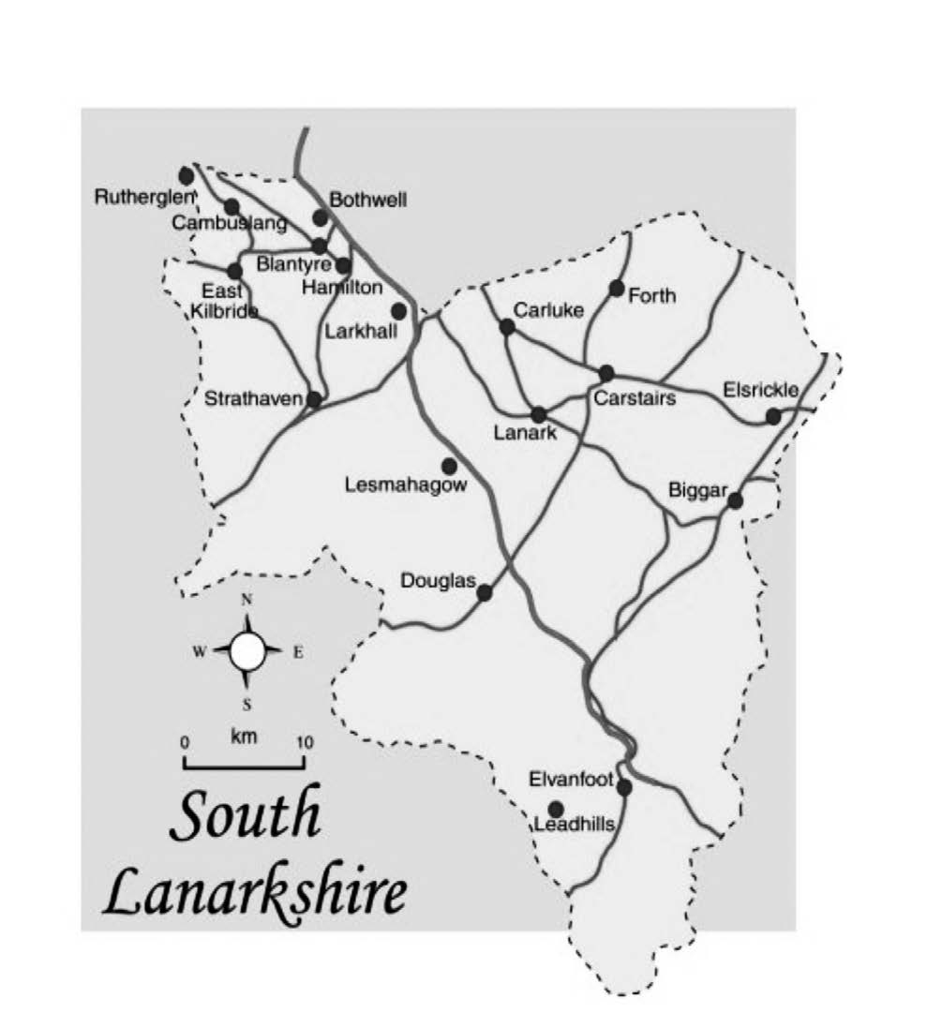
* you may want to print, or draw a map of the area that is relevant to the young person

Locations, people, places, and further details

I FEEL SAFE IN THIS AREA
I COULD BE SAFE IN THIS AREA
I DO NOT FEEL SAFE IN THIS AREA
SAFETY PLAN

APPENDIX E
Peer Group Map Exercise for Direct Work with Young Person (based on tool developed by Hackney)
Note: Peer mapping can support assessment and inform safety plans for young people. It should not be used solely as an information sharing tool.

You will need: A4 or A3 paper and pen or coloured pens
Step 1:
Ask the young person to draw a circle at the centre of the page that represents them.
Step 2:
Ask the young person to draw their friends or other young people they socialise with (their peers) on the paper around their circle. They should place them closer to, or further away from, their original circle depending on how close or distant their relationship is. See example below

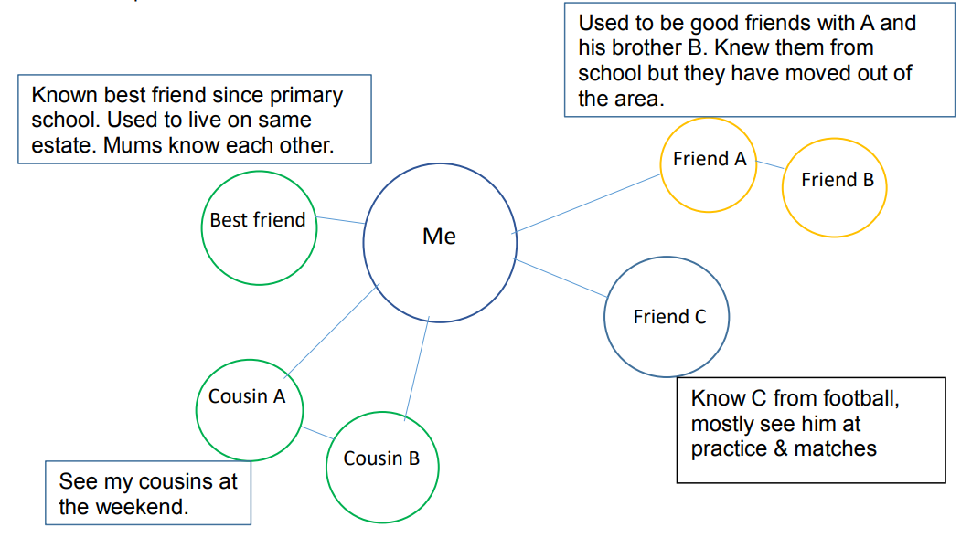

Step 3:
Use the map to explore the peer group dynamics with the young person. Ask questions about their friendships; find out more about the dynamics of their relationship, including any positive or negative influences. Examples of questions include:
• Who are you closest to?
• Who do you spend most time with?
• Who would you say is a positive influence on you?
• Are you a positive influence on someone?
• Out of all your friends, who would you trust to help you if you were in trouble?
• Out of this group, are there any friends that your parent/carer/teacher would say has a negative influence on you?
• Do you think you have influence over anyone?
• Are you friends’ parents/carers happy for you to spend time together?
• Do your parents/carers know your friends or their parents/carers?
• Have you ever got into trouble (at school, with the police, at youth club, etc.) with any of your friends?

As well as being an assessment tool, this exercise can be used to support planning by including step 4.
Step 4:
With the young person, think through strategies that will support them to build on the strengths in their peer group and to reduce the harm. For example, if the exercise has demonstrated that loyalty to a particular friend or group is causing young people to get into trouble with the police or teachers, are there ways that the young person can maintain that loyalty and friendship without engaging in negative activities? E.g. putting an agreement in place with their education establishment or their youth club for them to leave at a different time from their peers.

APPENDIX F
Peer Group Assessment Tool (based on template developed by Hackney Contextual Safeguarding Project)
1. Peer group details
Names of children/young people in peer group:
If child/young person is an open case indicate service/locality and lead professional.
Names of individual or organisational guardians in context:
(include name of school in which peer group exists and (head) teacher with knowledge of the group, or neighbourhood/place where they are known to spend time and other relevant professionals)
2. Assessment and consultation details
Date assessment started:
Names of parent/carers:

Date of contact with children, professionals and parents:
Reason for undertaking peer assessment:
(Where possible and relevant consider the views of the peer group; guardians (professionals and parents) about:
a) the context of the referral
b) what could be done to improve the situation)

3. Further details
 | Risk factors and pre-existing vulnerability factors | Resilience / strengths
Context background
- Extra-familial
Consider relevant information about the history of responding to extra-familial harm in the contexts in which the peer group spends time i.e. school/youth group or neighbourhood location. Have there been any significant historical events? Consider structural issues like the social-economic features of the context and experiences of discrimination like sexism and racism which might impact the norms and experiences in this peer group.
- Familial
Consider relevant information about the home/family characteristics of the peer-group members.
Diversity and Identity
Consider the diversity and identity needs within this peer group. Think about whether the group offers opportunity for those within it to explore and develop their personal identities (NB group identity is considered below)
Group Functioning
Using the Peer Assessment Triangle, consider the dynamics of the peer group, how they relate and their presentation to others in the following areas:
- Peer group identity (i.e. does the group see themselves as a group)

- Emotional and behaviour regulation (i.e. the mood/s in the group; how the group responds to each other’s feelings and emotions)

- Self-care and well-being (i.e. how the group takes care of its members; the norms within the group for social presentation)

- Social relationships of the group with those around them (i.e. how does the group interact with peers and adults around them and how are they perceived by others)

- Dynamics within the group (i.e. the interpersonal dynamics in the group)
Structural considerations
Using the Peer Assessment Triangle consider the following issues:

- Safety within the neighbourhood (i.e. where the group spends time; impact of the location on their safety)

- Relevant information about the peer-group’s parents’ integration within the local neighbourhood/context (i.e. do the parents of the group know one another)

- The impact of policy frameworks within the context (i.e. the impact of a school exclusion policy)

- Availability of resources (i.e. what can the group access)

- Wider systemic factors (i.e. any relevant historic factors in individual histories which relate to the current assessment such as adverse childhood experiences)
Guardianship Capacity
Using the peer group assessment triangle consider the following issues:

- Ensuring safety (i.e. who has responsibility for ensuring safety within the context and are they currently able to do so? Guardians ensure the peer group’s physical, emotional, psychological wellbeing)

- Caring investment (i.e. which adults have trusted relationship with members of the group and can provide appropriate boundaries and guidance to the group)

- Knowledge and understanding of safeguarding role (i.e. the extent to which relevant guardians have knowledge of and understand their safeguarding role and respond to harm).
4. Safeguarding capacity
Summary of issues affecting safeguarding capacity

5. Assessment of the situation
Assessment
(Consider the interplay between the different factors highlighted and which context has the greatest influence over the peer group)
Implications for each child/young person in the peer group
Recommendations regarding the need for any on-going work, including whether context intervention plan is needed
6. Views on assessment and suggested plan
Views of peer-group

Views of the guardians
Views of parent/carers

7. Plan
Summary of plan
Actions
(include ownership and timescales)
Outcomes
Assessment completed by
Date

Peer Assessment Triangle
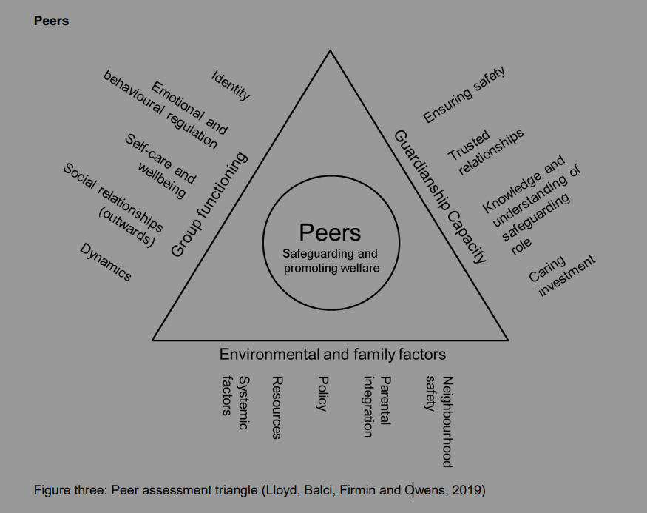

APPENDIX G
Location/Context Assessment and Action Plan
Assessment ref. |  | Referral: (summary of concerns that triggered the referral)
Method: (who was consulted, how/when/where)
Findings: |  | Vulnerability factors (pre-existing factors) | Risk factors (directly related to the issues in question) | Resilience factors / strengths
Refer to Neighbourhood Assessment Triangle | Environmental and community factors
Refer to Neighbourhood Assessment Triangle | Young person/peer group needs
Refer to Neighbourhood Assessment Triangle | Guardianship capacity
Identified interplay between above factors

Context-weighting decision
Assessment: |  | (summary of contextual concerns that will be addressed through intervention)
Plan: |  | (actions and ownership)
Monitoring and Outcomes: (include date for review)

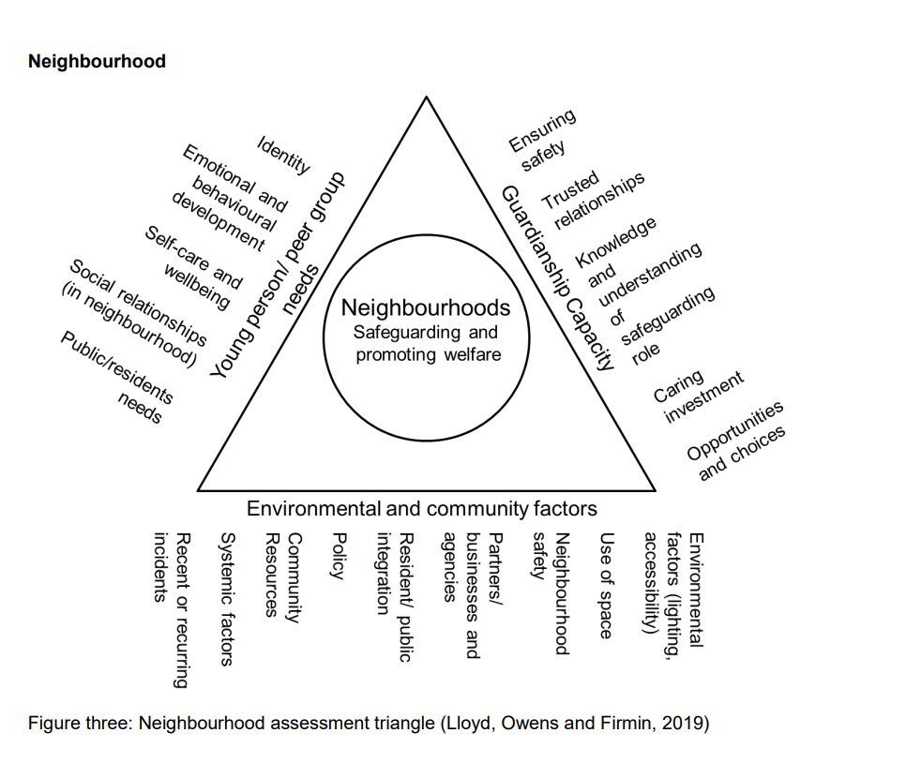
Neighbourhood Assessment Triangle
context-assessment-triangles.pdf

APPENDIX I
Additional Resources
The Contextual Safeguarding Network based at Durham University works with practitioners, young people and families to convert research into a range of resources and tools that help practitioners to make changes that improve responses to extra-familial harm.
Resources | Contextual Safeguarding
Toolkits | Contextual Safeguarding

APPENDIX J
Extra Familial Harm Definitions
Child Sexual Exploitation
Child sexual exploitation (CSE) is a form of child sexual abuse in which a person or persons of any age take advantage of a power imbalance to force or entice a child into engaging in sexual activity, in return for something received by the child and/or those perpetrating or facilitating the abuse. As with other forms of child sexual abuse, the presence of perceived consent does not excuse or mitigate the abusive nature of the act. ‘Child’ in this context means child or young person up to age 18. Boys as well as girls may be victims. Although CSE is not a specific criminal offence in itself, there is a range of criminal and civil options that can be used to disrupt and prosecute this form of abuse. national-guidance-child-protection-scotland-2021-updated-2023.pdf (www.gov.scot)
Children and young people in sexually exploitative situations and relationships are persuaded or forced to perform sexual activities or have sexual activities performed on them in return for gifts, drugs, money, or affection.
CSE can take place in person, online, or using a combination of both.
Young people have often been groomed into trusting their abuser and may not understand that they’re being abused.
Protecting children from sexual exploitation | NSPCC Learning
Article 34 of the UNCRC requires public authorities to undertake to protect children from all forms of sexual exploitation and sexual abuse, in particular, by taking all appropriate national, bilateral and multilateral measures to prevent:
- the inducement or coercion of a child to engage in any unlawful sexual activity
- the exploitative use of children in prostitution or other unlawful sexual practices
- the exploitative use of children in pornographic performances and materials 4.

Child Criminal Exploitation
Child Criminal Exploitation (CCE) is not defined in law but practitioners should be alert to the possibility that some children who are victims of trafficking may be exploited by gangs and organised criminal networks. CCE can be associated with ‘county lines’, which refers to criminal exploitation by gangs which export illegal drugs into one or more areas (within the UK). Gangs may use dedicated mobile phone lines or other form of ‘deal line’. Such gangs are known to exploit children and vulnerable adults to move (and store) drugs and money and often use coercion, intimidation, violence (including sexual violence) and weapons. However CCE can also occur in the absence of these features.
Practitioner Guidance on Criminal Exploitation (2023) has been published to support a shared understanding of criminal exploitation of children and adults, and to help assist with early identification of those at risk. The guidance has been developed by a subgroup of the Serious Organised Crime Taskforce; however, it equally applies to child criminal exploitation which is not linked to serious organised crime.
Child criminal exploitation takes a variety of different forms and affects both male and female children. It can include children being forced to work in cannabis factories, being coerced into moving drugs or money across the country, forced to shoplift or pickpocket, or forced to threaten other young people. Any child being forced or coerced to commit crime must be seen as a victim of exploitation. 4.351 Child criminal exploitation is often unrecognised and this can mean children are more likely to be prosecuted for offending behaviour, rather than being recognised as victims of exploitation. Children may fear arrest and prosecution. They may be drawn in to CCE through other children.
national-guidance-child-protection-scotland-2021-updated-2023.pdf (www.gov.scot)

Harmful Sexual Behaviour
Harmful sexual behaviour (HSB) is defined as “sexual behaviour(s) expressed by children and young people under the age of 18 years that are developmentally inappropriate, may be harmful towards self or others and/or may be abusive towards another child or young person or adult” (Hackett, 2014).
For further information national-guidance-child-protection-scotland-2021-updated-2023.pdf (www.gov.scot)

Violent Behaviour
The World Health Organisation (WHO) have defined violence as: “The intentional use of physical force or power, threatened or actual, against oneself, another person, or against a group or community, that either results in or has a high likelihood of resulting in injury, death, psychological harm, maldevelopment, or deprivation.”

Human Trafficking and Exploitation
Article 35 of the UNCRC requires public authorities to take all appropriate measures to prevent the abduction of, the sale of or traffick in children for any purpose or in any form; and Article 36 requires public authorities to protect the child against all other forms of exploitation prejudicial to any aspects of the child’s welfare.

The Human Trafficking and Exploitation (Scotland) Act 2015 defines trafficking as a ‘relevant action’ that Is taken with a view to another person being exploited. The offence of human trafficking is aggravated by being committed against a child.

A relevant action can include any of the following:
- Recruiting another person
- Transporting or transferring another person
- Harbouring or receiving another person
- Exchanging or transferring control over another person, or
- Arranging or facilitating any of the above actions.
It is irrelevant whether the person consents to any part of the action.

Examples of exploitation (in relation to human trafficking) include:
- Prostitution and sexual exploitation
- Criminal exploitation
- Slavery, servitude and forced or compulsory labour
- Securing services and benefits
- Financial exploitation/benefit fraud
- Removal of organs
- Debt bondage
- Begging

A child may not realise, divulge or agree that they have been trafficked or exploited.
national-guidance-child-protection-scotland-2021-updated-2023.pdf (www.gov.scot)

Travel between two places is not a requirement for an offence of human trafficking to have taken place. Trafficking occurs both within Scotland and between Scotland and other countries.

Further reading:
Criminal exploitation: practitioner guidance - gov.scot
Human Trafficking & Exploitation Guidance – Migration Scotland
Modern Slavery PEC | Children in Scotland: life after trafficking
Child Trafficking In Scotland (www.gov.scot)
National-Referral-Mechanism-Toolkit-March-2021.pdf (migrationscotland.org.uk)

Definition added June 2026
National Guidance for Child Protection in Scotland (2021 - Updated 2023)
My world triangle - GIRFEC wellbeing resources (SHANARRI) - gov.scot (www.gov.scot)
national-guidance-child-protection-scotland-2021-updated-2023-practice-insights.pdf
National Guidance for Child Protection in Scotland (2021 - Updated 2023)
Contextual Safeguarding Research Durham University.
Getting it right for every child (GIRFEC) - gov.scot
Getting it right for everyone (GIRFE) - gov.scot
5d-peer-group-assessments.pdf
Context Assessment Triangles | Contextual Safeguarding
A 10 step guide to sharing information to safeguard children | ICO
A guide to lawful basis | ICO
Safety mapping tool adapted from 3l-safety-mapping-exercise.pdf (contextualsafeguarding.org.uk)
5e-peer-group-mapping-guidance.pdf
Criminal exploitation: practitioner guidance - gov.scot (www.gov.scot)
Convention on the Rights of the Child text | UNICEF
Human Trafficking and Exploitation (Scotland) Act 2015: guide - gov.scot (www.gov.scot)

