South Lanarkshire Child Protection Committee

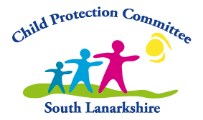

Annual Report 2022-2023 and Business Plan 2023 - 2024

Keeping Children & Young People Safe

www.childprotectionsouthlanarkshire.org.uk

Contents

PART 1 PAGE
 | Foreword - South Lanarkshire Child Protection Committee | 3
 | The work of South Lanarkshire Child Protection Committee  Public Protection  Achieving Outcomes – Our Activity (2022-2023)  SLCPC - Self-Evaluation & Quality Assurance  SLCPC – Child Protection Data Collection & Analysis  SLCPC – Training, Learning & Staff Development  SLCPC – Leadership, Governance and Accountability | 5  13  14  16  20  34  34
PART 2
 | SLCPC Business Plan 2023 – 2024 | 36

FOREWORD

THE CHAIR OF SOUTH LANARKSHIRE CHILD PROTECTION COMMITTEE (SLCPC)

As Independent Chair of South Lanarkshire Child Protection Committee (SLCPC), I am pleased to present the SLCPC Annual Report (2022-2023) and associated Business Plan (2023-2024) that details the work of the Child Protection Committee as a multi-agency partnership.

In the last year South Lanarkshire Child Protection Committee (CPC) responded to the pressures of the impact of three years of the pandemic and the recovery required to ensure the continuation of the wellbeing and protection of children, young people, and families. The pressures of high demand for public services and high levels of staff shortages across all public services has and remains an issue. These pressures have been made worse by the effects of a war in Europe, the Middle East, and the worst cost of living crisis for decades. Ensuring that the most vulnerable children remain visible to staff across services and continue to receive appropriate support remains a priority for all services. Procedures and guidance have been refreshed or introduced to address the impact of working with families during this difficult time.
As we move forward, we have been able to make changes to meet new challenges, this included a new data set (2022), implementation of the new National Child Protection Guidance, 2021- updated in (2023), the CPCScotland Self-Evaluation toolkit (2023), the new National Learning Review Guidance (2021), the Getting our Priority Right refresh (2022), the new Care Inspectorate Self-Evaluation Framework (2022), and a number of associated new guidance and legislation published by the Scottish Government. Meetings on digital platforms and occasionally in person has supported maximising attendance and there have been significant improvements in the range and sophistication of digital platforms and in the digital skills and experience of attendees.
Awareness raising campaigns designed to enlist the help of the public in looking out for children at risk of harm or abuse were refreshed and continued throughout 2022 and 2023. The Public Protection Newsletter is a monthly edition and continues to disseminate information, advice, and helpful links to resources for staff across the partnership. All the new publications by the Scottish Government were a major step in progressing the National Child Protection Improvement Programme (CPIP) which began in 2016. The programme also focuses on the leadership of child protection work across the partnership and in disseminating learning from case reviews.
Our work continues to be undertaken in partnership with colleagues in national and regional child protection forums. Strong partnership working continues to deliver good outcomes for the most vulnerable children in South Lanarkshire. The Child Protection Committee has close working ties with the other public protection groups within South Lanarkshire including the Adult Protection Committee (APC), the Violence Against Woman and Girls (VAWG) Strategic Partnership, Alcohol & Drugs Partnership (ADP), Community Justice Partnership (CJP) and Lanarkshire’s Multi-Agency Public Protection Arrangements (MAPPA). We also work closely with the Child Protection Committee of North Lanarkshire. This close working ensures we minimise duplication of effort and realise the benefits of a shared approach to continuous improvement of public services.
As with the previous year there has been a focus on Learning Reviews during the past year which provided learning to be progressed as areas of development within a multi-agency context. Quality assurance work continues to take place with ensuring a positive impact is achieved. The SLCPC Annual Report contains both national and local child protection performance and management information. We continue to develop the management information we hold within the Child Protection Committee. Such information helps us to identify trends, and practice issues and allows for comparison over time and with other local authorities. It provides us with evidence to support or review our policies and procedures and lets us see whether we are making a difference to the lives of children in South Lanarkshire.
I would like to thank all the members of the Committee and the Chief Officer Group for their continuing support and commitment to this work and to express a huge thanks to all staff across all agencies who work so hard to protect our children and young people every day. I also recognise the key role that everyone in our communities in South Lanarkshire play in supporting children, young people, and their families to keep them safe and protected and I look forward to continuing our work together in the coming year.

Safaa Baxter
Independent Chair
South Lanarkshire Child Protection Committee

- THE WORK OF SOUTH LANARKSHIRE CHILD PROTECTION COMMITTEE

  - Background

The South Lanarkshire Child Protection Committee (SLCPC) is the local strategic planning partnership responsible for developing and implementing child protection policy and strategy across and between agencies as described in the National Guidance for Child Protection in Scotland (2021) – Updated 2023.

The SLCPC performs a number of functions in South Lanarkshire as described in Scottish Government publication; Protecting Children and Young People - CPCs And Chief Officer Group Roles and Responsibilities Guidance (2019). This includes the development of policies, procedures, and protocols in securing the effectiveness and quality of local child protection services. The SLCPC provides high quality learning and development opportunities for a wide range of professionals, practitioners, and managers. It actively contributes to national work and embeds learning from national and local activity in striving for improvement across the child protection workforce.

The core business function of SLCPC is linked to continuous improvement in the context of a set of quality indicators, as referred to in the current Care Inspectorate Guidance (2022) and provides a framework for evaluation across the partnership. The quality indicators have three inter-connected aspects:

- The impact that services have upon the lives of children and young people in need of care and protection and the outcomes achieved
- The processes that support them
- The individual and collective vision and leadership of those services

The role of SLCPC and its partners is to support community planning partnerships and key strategic groups by working together in the delivery of services for children, young people in need of care and protection

South Lanarkshire Committee (SLCPC) hold four business meetings a year with two additional development sessions that offer time to focus in detail on key national and local matters of interest. This work is supported by a number of multi-agency task groups who consider and respond to local and national child protection matters within agreed workplans.

We have embedded the National Minimum Dataset for Child Protection Committees in Scotland to our programme of work. This dataset provides information on trends and emerging issues in the protection of children. The analysis of this data informs multi-agency child protection strategy.

We routinely report to the Chief Officers Group (Public Protection), the Integrated Joint Board (IJB), the Children’s Planning Partnership (CPP) and the GIRFEC Partnership Board to ensure outcomes are being achieved and Article 12 (UN Convention on the Rights of the Child, 1989) is applied in all our work.

ARTICLE 12 (UNCRC)
Every child has the right to express their views, feelings and wishes in all matters affecting them, and to have their views considered and taken seriously.

This principle recognises children and young people as actors in their own lives and applies at all times throughout a child’s life. The SLCPC Task Groups and Joint Public Protection Task Groups have pivotal roles in reflecting on and adapting practice, while progressing evidence-based improvement plans. Through our local structures and membership, we provide individual and collective leadership and direction for the management, quality assurance and continued improvement of child protection services.

  - Continuous Improvement

Self-evaluation is central to continuous improvement. It is a learning process by which those who are responsible for improving services for children and young people in need of care and protection get to know how well they are doing. It can also help to identify the best way to improve their services.

Opportunities to undertake joint self-evaluation are maximised in South Lanarkshire and aligned to multi-agency planning and reflected in the children’s service plan as well as the child protection committee.

Self-evaluation helps to establish a baseline from which to plan to improve outcomes for children, young people, and families. Establishing how to make improvements in outcomes for children, young people, and families, and how to measure these, is the central aim of self-evaluation. The focus for SLCPC are those areas of greatest concern and have the most negative impact upon children and young people.

The continuous improvement programme is set out annually and considers current issues arising from Local and National areas for learning; this programme allows the CPC to measure against best practice across Scotland. It also provides the partners with an indication of how good the child protection system within South Lanarkshire is and influences how we set targets for improvement. There are a number of planned self-evaluation activities for the coming year which will be overseen by the SLCPC Quality Assurance Task Group. These can be viewed in our Business Plan (Appendix 1).

The Management Information Task Group retains an overview of information from key agencies relating to the protection of children and young people in South Lanarkshire.

SLCPC works closely with the Getting It Right for South Lanarkshire’s Children’s (GIRSLC) Continuous Improvement Group in their oversight of self-evaluation and improvement activity.

The established Inter-Agency Referral Discussion (IRD) Audit Task Group work to ensure that all those referred into the IRD system benefit from good quality collective decision making when proceeding with Notifications of Child Protection Concern (NOCPCs). We also focus on those Notifications NOCPCs that do not go to IRD to aid our understanding on decision making processes. Our evaluation process has informed the partnership what areas are developing well and where more focus is required.

  - Policies, Procedures and Protocols

The SLCPC designs, develops, publishes, distributes, disseminates, and regularly reviews and evaluates clear and robust multi-agency child protection policies, procedures, protocols, and guidance to ensure that they support practice and service delivery. We routinely develop public protection guidance across child and adult protection In South Lanarkshire. We ensure that child protection policies, procedures, protocols, and guidance are developed around national and local work, fit with legislative frameworks, and reflect the principles of GIRFEC alongside existing and emerging key issues that inform our practice at local level.

The SLCPC is supported by Task Groups. Each Task Group is subject to regular scrutiny and has a set of priorities embedded in its work. Action plans are reported quarterly to the SLCPC and to Public Protection Chief Officers Group as required.

The multi-agency workforce is encouraged to use their own agency Child Protection procedures and to also refer to the new South Lanarkshire Multi-Agency Child Protection procedures published in 2023, in carrying out their child protection responsibilities. Specific topic related guidance developed by the SLCPC around key areas, support these.

  - Promoting Good Practice

The South Lanarkshire Child Protection Committee has a responsibility to identify and promote good, evidence-based policy and practice developments, encourage learning from effective publications and to identify areas that need to be strengthened. The SLCPC has:

- Identified networks, mechanisms, and opportunities to share lessons across South Lanarkshire and Nationally.

- Fully implemented the National Guidance for CPCs Undertaking Learning Reviews Scotland (2021) and ensured robust mechanisms are in place for the identification, consideration and undertaking of Learning Reviews and Reflective Learning Reviews on behalf of the South Lanarkshire child Protection Committee and the Chief Officers Group Public Protection. Overseen by the SLCPC Strategic Case Review Sub-Group.

- A number of processes are in place to identify good practice and disseminate lessons learned from past and current practice.

- Work jointly across public protection wherever possible, including the Annual Public Protection events focussed on Leadership and Development.

- Continued to work with Public Protection COG (PPCOG) by undertaking a self-evaluation exercise with PPCOG, to create more ways to celebrate success and use it to strengthen partnership working at every opportunity.

- Work collaboratively across Lanarkshire in areas of interest, for example Contextual Safeguarding, Neglect, and the Interagency Referral Discussion.

  - Learning and Development

The SLCPC ensures that its multi-agency teams have the necessary range of skills and professional expertise to carry out the child protection task. Child Protection training and staff development is undertaken at both single agency and multi-agency level to support the workforce in building their skills and knowledge, and in fostering a common understanding in child protection work. Through the SLCPC Learning and Development Task Group, promotes, commissions, and assures the delivery of quality multi-agency training. We have continued to build on our learning and development opportunities over the past year and can evidence that we are making a difference.

- We value the importance of professional judgement in dealing with the risk and uncertainty of child protection situations.

- The SLCPC has a dedicated Child Protection Learning & Development Worker who alongside members of the Joint Adult & Child Protection Learning and Development Task Group, evaluates, develops, and delivers high quality training. Attendance is maintained at very good levels and quality assurance results are high in terms of course choices, availability and learning outcomes.

- We can evidence that as a result of learning with us, staff and managers tell us it has a direct positive impact on outcomes for children and young people.

- The Learning and Development Task Group undertook a Training Needs Analysis in respect of Child Protection Learning and Development which included consultation from all SLCPC agencies in November and December 2021. The findings from this analysis have been incorporated into the Learning and Development Action Plan which is managed by the Learning and Development joint SLCPC & SLASPC Task Group.

The South Lanarkshire Public Protection Learning and Development Programme was published in January 2023;

Our Learning and Development Worker and the associated worker for the Violence Against Women and Girls Partnership were trained as associates in the Safe and Together Model in July 2022 and are now certified to deliver the Core, 1 Day overview and 1 hour briefing sessions. The first cohort of the Core Safe and Together Training took place in September 2022 and work has successfully continued at pace since.

In association with Action for Children, the Learning and Development Task Group worked to update and review the Neglect Assessment Toolkit for the identification, measurement, and assessment of neglect as a component of care. We continue to support the Wellbeing work of Children’s Services.

SLCPC, SLAPC as partners of the Chief Officers Group (Public Protection) have agreed to host a large-scale public protection event across North and South Lanarkshire and will focus on leadership and practice in early 2024. .

1.6 Public Information

- Raising Public Awareness

A priority of SLCPC is to maximise connectivity and visibility with children, families’ communities, and frontline staff. The SLCPC routinely works to improve levels of public awareness, understanding and knowledge of, and confidence in child protection systems. We have promoted our work in each of our four localities and engaged with communities around the theme of “Keeping Children Safe”. Including creating a suite of information for children, young people, and families about keeping safe on social media platforms.

The SLCPC continues to design, develop, publish, distribute, disseminate, implement, and regularly review its work, to improve how we keep the public informed and keep children and young people safe. We listen to children, young people, families, communities, and our workforce to produce public information about protecting children and young people.

The Joint Adult & Child Protection Public Information and Community Engagement Task-Group works to enhance and improve levels of public awareness in the public protection agenda, and continue to identify ways to further engage children, young people, adults, and carers in our work.
We continue to support CPCScotland campaigns aimed at communities throughout the year including those routinely updated on the CPCScotland website.

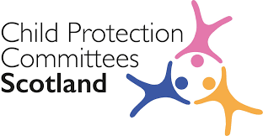

- Involving Children, Young People, and their Families
The SLCPC ensures that the views of children, young people and their families are evidenced in its work, in accordance with GIRFEC principles. We have strengthened our processes over time to ensure we uphold the rights of children and young people including the introduction of the Mind of My Own App, which continues to offer outstanding results.
Our aim is to involve children and young people in the design, development, and implementation of SLCPC communications to ensure that information is accessible, and that children's experiences and perspectives are properly reflected.
  - Getting it Right for Every Child in South Lanarkshire (GIRFEC)
By applying the principles of GIRFEC, we want children and young people in South Lanarkshire to be safe, healthy, achieving, nurtured, active, respected, responsible, and included. We are making considerable effort to promote and evidence with our partners through auditing the child’s plan, a shift from routine reporting of outputs to clear evidence of impact and desired outcomes being met throughout multi-agency frontline practice.
Sources of evidence we consider are multi-agency chronologies, risk assessments, the views of children and families, core group activity, initial referral discussions and contingency planning across the partnership.
SLCPC led on a comprehensive review of multiagency processes in assessing and responding to risk, while achieving outcomes for the children and families involved. We further examined paperwork and processes for consistency in practice. An CP Assessment Checklist was developed to support frontline staff when undertaking child protection investigations. This is used widely across locality areas.
  - Our Vision - Keeping Children Safe
Children and young people in South Lanarkshire have the right to be cared for and be protected from abuse and harm in a safe environment where their rights are respected. All agencies work together in a collaborative way to promote the safety and wellbeing of children and young people in South Lanarkshire.
The SLCPC supports national and local outcomes in the protection of children and the supports the GIRFEC approach to wellbeing to ensure that we improve the life chances for children, young people, and families at risk. The introduction the Children (Equal Protection from Assault) (Scotland)Act 2019 and its associated guidance developed by SLCPC with its partners in North Lanarkshire CPC is one example of its commitment to keep children safe, shared and adopted nationally as a good practice guidance for professionals is one example of our commitment to children in our communities.
We recognise, respect, and promote children’s rights. These include rights to be treated fairly, to be heard and to be as healthy as possible.
Parents and families, communities, local and national governments, and organisations which work with children and families, all play a critical role in helping children understand and experience their rights. Our multi-agency practice is clear that we must ensure that children enjoy their rights, as set out in the United Nations Convention on the Rights of the Child (UNCRC).
We work closely with Child Protection Committees Scotland and regularly share public messaging aimed at keeping children safe.
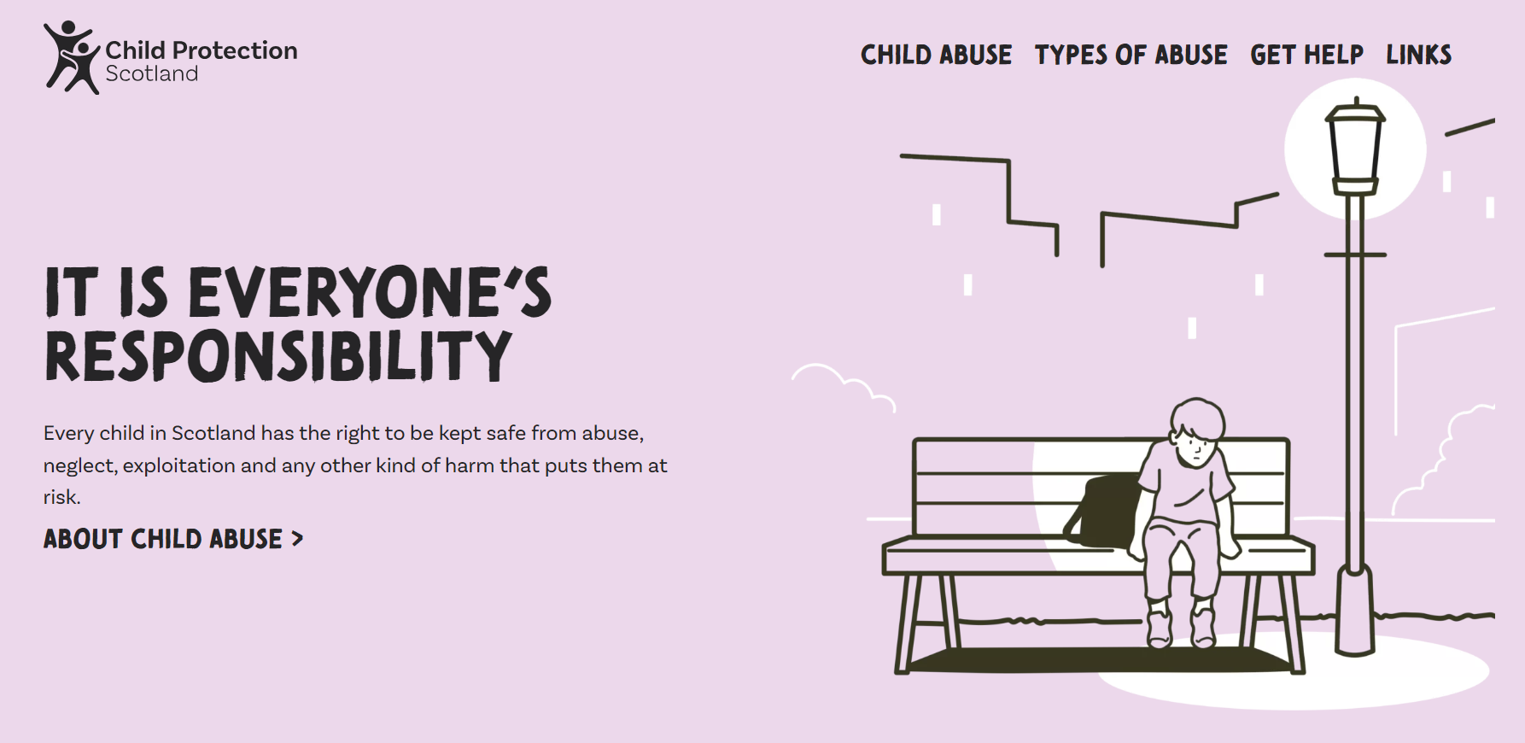

Source: www.childprotection.scot

With our partners in Children’s Services, we encourage and welcome a proactive culture in making children’s rights central to our work. We are confident that by working together a rights-based approach can make a significant difference to children and young people’s lives.

- PUBLIC PROTECTION

  - Public Protection

Public Protection South Lanarkshire |  |  |  | Community Planning Partnership Board
 | CHILD PROTECTION | ADULT PROTECTION | MAPPA | ADP | VAWG

NB: MAPPA – Includes Offender management ADP – Alcohol & Drug Partnership VAWG – Violence Against Women and Girls Partnership, and links to Community Justice Partnership
The contribution of South Lanarkshire Child Protection Committee to strategic planning falls into the following two broad categories:
- Making and Maintaining Links with other Planning Forums
SLCPC forms part of the Public Protection Team in South Lanarkshire and has established key links with other bodies to ensure that plans and priorities are clearly linked to other national and local priorities.
Partnership working continues to deliver services and supports that promote outcomes for the most vulnerable children in South Lanarkshire. SLCPC works closely with the wider Public Protection Teams. Additionally, our work is link across Public Protection to reflect the Community Justice Partnership.
- Communication, collaboration, and co-operation
Effective communication, collaboration, and co-operation, both within and between practitioners, managers and senior officers across all services and agencies, remain essential for the protection of children and families as described in our Communications Strategy. You can contact us here for a copy. The Committee will continue to raise awareness of Child Protection and its links to Public Protection. It continues to report to a number of key multi agency forums within South Lanarkshire.
- OUR ACHIEVEMENTS

  - Achieving Outcomes – Our Activities (2022-2023)

Reflecting on the previous SLCPC Business Plan we completed a number of self-evaluation tasks and developed further how we deliver child protection support to children, young people, and their families.

Examples of how we have met the quality requirements set out in the Care Inspectorate’s Quality Framework for Children in Need of Care and Protection (2022).

- We continue to provide evidence through multi-agency case file audits that from birth, we are improving how we actively listen and take into account what children, young people and babies tell us about their world. This included a revision of our Participation and Engagement Strategy, further updated in 2021. We have acknowledged significant improvements will be made by the inclusion of advocacy opportunities for children in relation to the child protection process.

- We used the Mind of My Own App for some of the year before moving to work in in partnership with Who Cares - Scotland This service is already working with looked after children. We introduced a new advocacy service for those children subject to Child Protection Investigation. Advocacy is offered to the young person ahead of the first Child Protection Planning Meeting (CPPM) and continues on the journey with a child subject to child protection registration to ensure their voice is heard.

- Through various quality assurance methods, we have noted a significant increase in the use of both the qualitative and quantitative information gathered by the multi-agency workforce at the time a child protection event occurs. This is supported by the implementation of the National Shared Data Set for CPCs in Scotland.

- We found continuing evidence in the use of the National Risk Assessment Framework and will continue to support the workforce in the use of the tool including the resilience matrix.

- We produced new multi-agency child protection guidance to support the introduction of the National Guidance for Child Protection in Scotland (2021) – Updated 2023. This was supported by large-scale learning events for over 400 staff.

An audit on the communication between our Community Addiction and Recovery Service (CAReS) and Children’s Services outlined the need to improve the reports provided by CAReS for Child Protection Planning Meetings. CAReS adapting their report to ensure that they are proportionate and effective in the sharing of information to inform decision making and care planning for children and young people. This is now fully implemented.

There were two Learning Reviews undertaken by the Committee in the period covered by this report in August 2022 – July 2023. These findings have assisted us to reflect on what works well and where improvements in communication, accountability, and a shared contribution to child protection work is required.

During self-evaluation activities, we found multi-agency assessments demonstrate improved intervention methods with children, young people and families who are fully engaged in the process. The use of contingency plans is improving overall and aims to ensure children and young people have increased opportunity to have their say. The child protection workforce demonstrates a strengthening picture around outcomes planning and work SMART to ensure they have demonstrable evidence on the impact of intervention.

A strengthened Joint IRD Guidance for use Pan Lanarkshire was developed and published in June 2022. An opportunity to routinely evaluate those cases that do not proceed to IRD was also established. The refresh of the Pan Lanarkshire IRD guidance has since been further updated in 2023 to meet the requirements of the new National Guidance for Child Protection including updates to Equal Protection processes described in the Children (Equal Protection from Assault)(Scotland) Act 2019. The application of the new CP Guidance is monitored by the SLCPC Inter-Agency Referral Discussion (IRD) Audit Task Group to ensure that it is implemented effectively and the workforce has the capacity and the resources required.

We have continued to deliver learning opportunities to the child protection workforce in a number of creative ways. We have a virtual / hybrid and in-person training programme which offers a range of learning opportunities for staff across the partnership.

The development and implementation of our Neglect Toolkit is an example of best practice and has not only been promoted across South Lanarkshire and neighbouring authorities, but across Scotland via CPC Scotland. The findings have been shared across various groups, and South Lanarkshire’s approach to introducing and using this toolkit are now being echoed in a number of other areas. The toolkit is perceived to be significant in not only child protection work, but also in early intervention and preventative work with children and families.

- SELF EVALUATION & QUALITY ASSURANCE

  - SLCPC Outcomes Model
In 2022 / 2023 we further strengthened our resources and:

- Continue to implement the Neglect Toolkit

- The Community Addictions and Recover Service (CAReS) reports for the Child Protection Planning Meeting (CCPM) has now been re-developed for use.

- We continue to focus on routine quality assurance, measuring impact and improving outcomes.

- Worked jointly with the APC in carrying out a self-evaluation tool for the Chief Officers Group (Public Protection).

- We analysed the information available from our quality assurance work and agreed to concentrate on five themes: assessment, risk assessment, care planning, chronology, and the voice of the child/young person.

  - Joint Self Evaluation & Activity Programme

The quality indicators set within the Care Inspectorate’s – Quality Framework for Children in Need of Care and Protection Framework (2022) is to support self-evaluation of services for children and young people in need of care and protection and is designed to lead to improvement in services. It places the child at the centre of self-evaluation and looks at the impact that services can have on a child’s life as well as the positive outcomes that they can lead to.

The SLCPC has in place an ambitious annual programme of multi-agency audit and self-evaluation activity that takes cognisance of national priorities and local requirements including quality indicators and emerging issues from the National Child Protection Improvement Programme.

SLCPC AUDIT EXAMPLES

- Child Protection & Housing Audit

In late 2022, the Lead Officer Child Protection, Development Officer Child Protection and Strategy Co-ordinator Housing and Technical Resources met to discuss the purpose and intended outcome of the small-scale audit. It was agreed the focus would be on representation of Housing and Technical Services invited to attend child protection case conferences and their role in subsequent safety planning.

Areas of Strength
- Housing Services were attended or involved with 100% of the cases audited either through the Child Protection investigation or Case Conference Meetings. Shelter and Breaking the Cycle Housing support services were involved in some of the cases as additional support.
- A good practice example was identified where it was evident throughout the Child Protection Investigation that communication, sharing of information and joint visits / between relevant agencies involved in the investigation had been excellent.
- Information contributed by Housing Services was relevant and proportionate to the Child Protection Investigation / Review Assessment / Case Conference.
- Partners worked effectively with housing services during the course of the CP Investigation in achieving the right support at the right time for families

Next Steps

Working with the Quality Assurance Task Group we have agreed to focus on a guidance refresh for Housing & Technical Services to ensure full inclusion in any child protection meeting. We will also ensure that information is routinely sought from Housing & Technical Services for the Child Protection Investigation where more detailed discussion / information from Housing Services will service to inform assessments.

- Emotional Abuse Multi-Agency Case File Audit

In January 2023, South Lanarkshire Child Protection Committee (SLCPC) conducted a multi-agency case file audit of cases where children and young people were affected by Emotional Abuse. 18 cases were identified from across 5 locality areas. The multi-agency audit team were trained in the use of the new Care Inspectorate Quality Improvement Framework Toolkit (2022). The auditors included representatives from Social Work, Health, Education and Police.

The findings and outcome measures identified from the audit were analysed by SLCPC Quality Assurance and Management Information Task Group and made available to the Chair of SLCPC and its members prior to being presented at Chief Officers Group (public Protection). The Child Protection Development Worker collated all the qualitative and quantitative data and held a focus group with the audit team before submission. All practitioners whose cases were involved will be provided with a briefing where key findings will be discussed.

In 55% of the cases the children were currently on the Child Protection Register (CPR) - at the time of the file reading. In 45% of cases (under half) the children had been deregistered from the CPR in the past 12 months.

The majority of the children were supported by a multi-agency plan with a lead professional. Whilst we knew 100% were affected by Emotional Abuse, we found 94% were affected by Domestic Abuse and Parental Mental Health, 78% were affected by members of families who agencies struggle to engage with, 66% were affected by Parental Drug use, 61% affected by Physical Abuse and Neglect, 44% were affected by Parental Alcohol use and 11% affected by Sexual Abuse.

Areas of Strength

- Evidence of good multi-agency working in most cases.
- Inter-agency Referral Discussion (IRD) was undertaken in almost all cases.
- Almost all cases have an assessment of needs, protective concerns, and risks.
- All cases held either a single or multi-agency chronology.
- A multi-agency plan was in place in almost all cases to manage the needs, protective concerns, and risks for the child.
- Advocacy support was utilised to support children
- Good practice examples were identified

Next Steps

Whilst good practice examples were evident. the SLCPC, working with the Quality Assurance Task Group have agreed to consider further improvements in ensuring the views of young people are always recorded in all case records.

- Contextual Safeguarding Audit

Contextual Safeguarding is an approach to understanding and responding to children's experiences of significant harm beyond their family and home. This approach recognises the different relationships children have in their schools, peer groups, online and in their community. As part of the implementation of a contextual safeguarding approach within South Lanarkshire, an audit was agreed to examine the current multi-agency response to extra-familial harm. The findings will be used to examine the current situation within South Lanarkshire and highlight what next steps should be prioritised.

The small -scale audit took place from in July 2023. The Audit Team comprised of a representative from social work, health, education, and police. An audit tool was compiled by the Contextual Safeguarding short life working group with questions designed to examine evidence for how effectively the multi-agency group currently respond to young people at risk of extra-familial harm. Findings included:

- In 100% of cases there was evidence of the young person’s view being sought using a range of strategies. There was also evidence that the parents’ views were sought in 83% of cases.
- Pattern mapping and tools were used in 100% of cases, the most common being a CSE matrix,
- Multi-agency planning was evident with young people being supported by services such as the GIVIT, CAMHS, Family Nurse Partnership and the health and homeless service.
- In 100% of the cases, appropriate procedures were used to mitigate risk to the young person such as four-weekly risk management meetings,
- The IRD process was assessed as being effective in identifying risk and action required in 83% of the cases.
- 33% of the young people with a diagnosed or suspected neuro diverse profile were in receipt of CAMHS services.
- Eighty-three percent of the young people had accrued offence charges linked to distressed behaviours associated with Child Sexual Exploitation, Child Criminal Exploitation, and peer on peer abuse.

Good Practice Example

Auditors noted the level of in-depth work with a number of cases which had clearly led to a reduction in risk and positive outcomes for the young people involved. They acknowledged the intensive level of work required in order for these outcomes to be achieved and were keen that this continued to be supported by specialised teams within social work services.

Next Steps

The SLCPC working with the Contextual Safeguarding Group have agreed to conduct a mapping of current processes in response to extra-familial harm. Work will also continue in the implementation of Contextual Safeguarding in South Lanarkshire. Discussion will also take place with Adult Services in relation to transitional arrangements for young people with continued support needs moving into adulthood.

  - Action Plans

There has been evidence-based improvement through a variety of audits in relation to action plans. The focus is not only on the development and completion of actions plans but about showing evidence of sustained change over time. We continue to take opportunities to ensure actions are carried out where possible without delay. We seek tangible evidence of the improvements being made. We work SMART in doing so to avoid drift and ensure actions are concluded and sustained.

Self-evaluation continues to help to establish a baseline from which to plan to improve outcomes for children, young people and families as well as promoting a collective commitment to set priorities for improvement.

4.4 Learning Reviews

We have fully implemented the National Guidance for Undertaking Learning Reviews in Scotland (2021). There were two Learning Reviews undertaken by the Committee in the period covered by this report in August 2022 – July 2023. Suggested strategies from these Learning Reviews are reported to the Public Protection Chief Officers Group and progressed by the SLCPC.

SLCPC examined recommendations and suggested strategies from key national enquiries and also considered areas of good practice which resulted from both national and local Learning Reviews carried out in other parts of Scotland and the UK. The findings from each were fully examined and practice or policy improvements were made in light of the Reviews carried out where applicable.

All activity is overseen by the South Lanarkshire Strategic Significant Case Review Sub-Group who are a sub-group of the SLCPC and act on behalf of the Public Protection Chief Officers Group (PPCOG).

- CHILD PROTECTION DATA COLLECTION AND ANALYSIS

5.1. National Child Protection Statistics

Children and young people aged 0 – 15 years living in South Lanarkshire, make up 17% of the population. In 2021, there were 3,109 births. This is an increase 6.6% from 2,918 births in 2020. Of these 3,109 births, 1,494 (48.1%) were female and 1,615 (51.9%) were male. South Lanarkshire has on average of 142 children on the Child Protection Register at any one time. Slightly more boys than girls required care and protection both nationally and locally. A higher number of children needed the support of more than one service and had a multi-agency child’s plan.

The information collected from local authorities and secure units is about children and young people who were formally looked after, under child protection measures, or in a secure care placement between 1st August 2021 and 31st July 2022.

In the period 2021 - 2022 the Annual Report on National Child Protection Statistics (published 2023) shows that across Scotland, as of 31 July 2022:

- 2,031 children were on the Child Protection Register – down 4% on 31 July 2021.

- During 2021-22, 3,286 children were newly registered onto the Child Protection Register – down 5% on 2020-21.

- The most common concerns identified at Case Conferences of children registered during the year were: domestic abuse, neglect, parental substance misuse and parental mental health problems

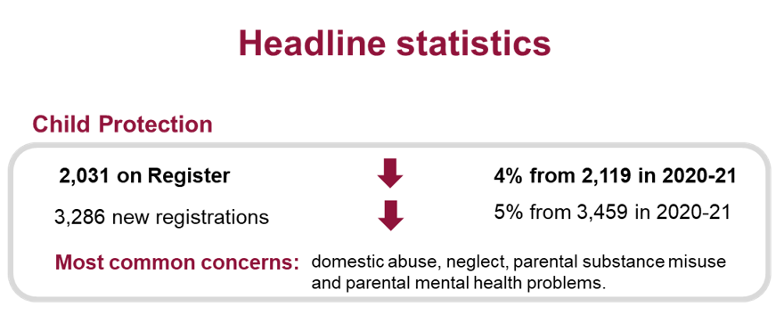

5.2 Child Protection (National data)

The route of child protection processes is summarized in Figure 1.
Figure 1 Children included in child protection statistics

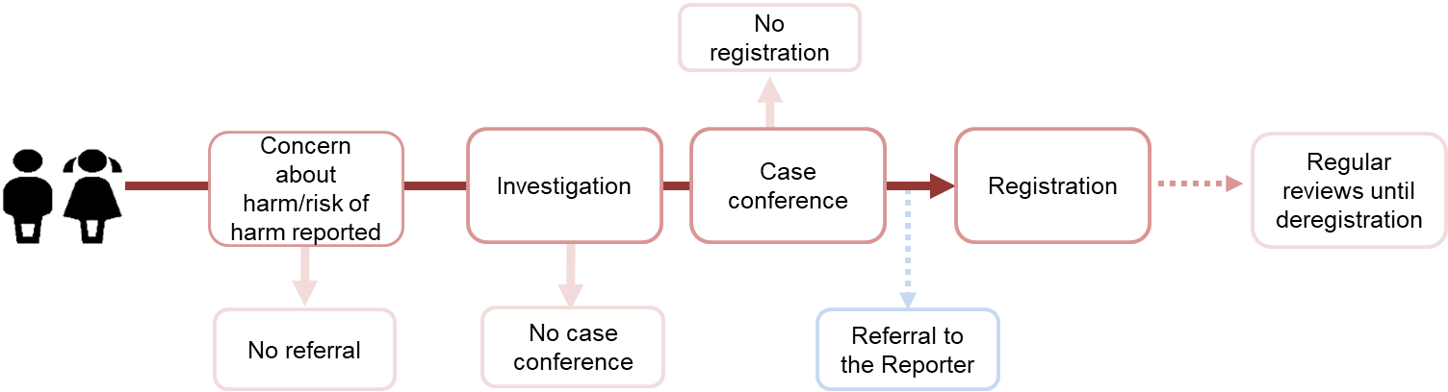
Concern about harm or risk of harm reported may lead to an investigation (or no investigation) which may in turn lead to a case conference (or no case conference). A case conference (now referred to as a Child Protection Planning Meeting) may lead to registration (or no registration) and may also lead to a referral to the Reporter. If a registration takes place, there will be regular reviews until de-registration.
The National Minimum Shared Data Set for child protection continues to guide our understanding of trends and influences in practice (see 5.4).

5.3 National Minimum Data Set for Child Protection Committees

The National Minimum Dataset for Child Protection Committees is an action from the Scottish Government’s Child Protection Improvement Programme and sets out the need to deliver robust data sets to support child protection improvement and offer national resource for advice on using child protection data for local planning and service development.

The data set expands analytical capacity on the indicators reported to the Child Protection Committee. This is managed by the SLCPC Management Information task Group and reported to the SLCPC and Public Protection COG.

5.4 How do children come to be counted in child protection figures?
The diagram below gives a high-level illustration of the main routes by which children would be included. Please note this national graphic does not include IRD which is applied locally.
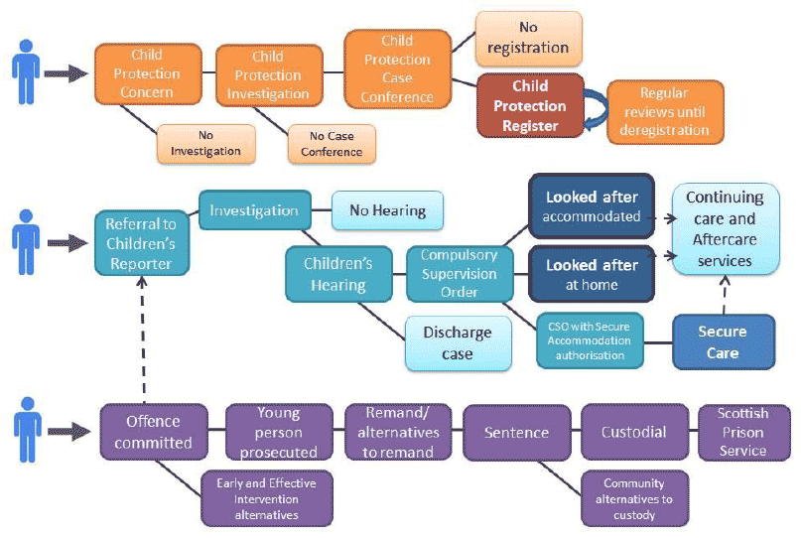

5.6 Child Protection Register (per 1,000 pop in South Lanarkshire 2016 – 2022)

CPR  2016 | POP | CPR  2017 | POP | CPR  2018 | POP | CPR  2019 | POP | CPR  2020 | POP | CPR 2021 | POP | CPR 2022 | POP
162 | 3.0 | 140 | 2.5 | 180 | 3.3 | 116 | 2.1 | 157 | 2.8 | 116 | 2.1 | 106 | 1.9

The Service Manager Children & Justice (SWR) is South Lanarkshire’s Keeper of the Register. The National Child Protection Statistics for Scotland report on the year prior to the report published. In the period 2021-2022 it shows South Lanarkshire – 1.9 per 1000 of population. This is considerably lower than the previous year. The national average per head of child population is 2.2.


5.7 Child Protection Register (Scotland)

On 31 July 2022, 2,031 children were on the Child Protection Register. This is a 4% decrease since 2021 and the lowest this figure has been since 2002 (see Chart 1).
Number of children on the Register by age, 2000-2022

(a) Characteristics of children (Scotland)
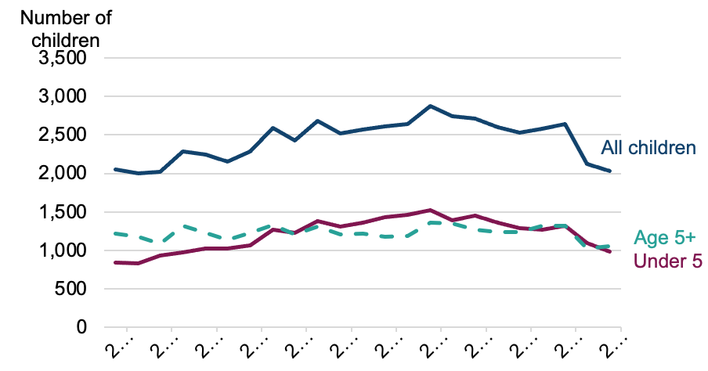
Of those children on the Register on 31 July 2022, 50% were male, 45% were female, and 5% were not yet born, as seen below, the proportion of children on the Register aged under 5 years has decreased from 52% in 2021 to 48% in 2022, while the number of children aged 5 years and over has increased from 48% in 2021 to 52% in 2022.
(b) Number and percentage of children on the Child Protection Register by sex and age, on 31 July 2022 (Scotland)

Sex and age | 2012  Number | 2012 Percentage | 2021  Number | 2021 Percentage | 2022  Number | 2022 Percentage
Sex
Male | 1,335 | 49% | 1,019 | 48% | 1,006 | 50%
Female | 1,268 | 47% | 994 | 47% | 922 | 45%
Unborn [Note 2] | 93 | 3% | 106 | 5% | 103 | 5%
Unknowns | 2 | 0% | 0 | 0% | 0 | 0%
Age
Unborn | 93 | 3% | 106 | 5% | 103 | 5%
0-4 | 1,340 | 50% | 990 | 47% | 876 | 43%
5-10 | 765 | 28% | 681 | 32% | 677 | 33%
11-15 | 407 | 15% | 330 | 16% | 353 | 17%
16+ | * | * | 12 | 1% | 22 | 1%
Unknown | * | * | 0 | 0% | 0 | 0%
Total | 2,698 | 100% | 2,119 | 100% | 2,031 | 100%
[Note 1] Some totals may not exactly equal the sum of their parts due to the effects of rounding. [Note 2] Unborn children with both a known and unknown sex.

- Number and percentage of children on the Child Protection Register by sex and age, on 31 July 2022 (Local)

 | 2012 | 2012 | 2021 | 2021 | 2022 | 2022
Sex and Age | Number | Percentage | Number | Percentage | Number | Percentage
Sex
Male | 78 | 47% | 55 | 47% | 52 | 49%
Female | 80 | 48% | 61 | 53% | 54 | 51%
Unborn | 7 | 4% | 0 | 0% | 0 | 0%
Unknown | 0 | 0% | 0 | 0% | 0 | 0%
Total | 165 | 100% | 116 | 100% | 106 | 100%
Age
4 and under | 76 | 46% | 53 | 46% | 41 | 39%
5-10 | 66 | 40% | 41 | 35% | 38 | 36%
11-15 | 23 | 14% | 21 | 18% | 21 | 20%
16+ | 0 | 0% | 1 | 1% | 6 | 6%
Total | 165 | 100% | 116 | 100% | 106 | 100%

- Number and rate per 1,000 children on the Register by local authority, on 31 July 2022

Local authority | 2012  Number | 2012  Rate | 2021  Number | 2021  Rate | 2022  Number | 2022  Rate
Aberdeen City | 87 | 2.7 | 83 | 2.3 | 115 | 3.2
Aberdeenshire | 73 | 1.5 | 73 | 1.5 | 89 | 1.8
Angus | 59 | 2.9 | 45 | 2.4 | 59 | 3.2
Argyll and Bute | 48 | 3.3 | 32 | 2.6 | 21 | 1.7
City of Edinburgh | 223 | 3.1 | 97 | 1.2 | 104 | 1.3
Clackmannanshire | 55 | 5.9 | 41 | 4.6 | 15 | 1.7
Dumfries and Galloway | 94 | 3.7 | 34 | 1.5 | 41 | 1.8
Dundee City | 82 | 3.5 | 84 | 3.5 | 61 | 2.6
East Ayrshire | 73 | 3.4 | 69 | 3.3 | 80 | 3.8
East Dunbartonshire | 23 | 1.2 | 23 | 1.2 | 35 | 1.8
East Lothian | 62 | 3.3 | 29 | 1.5 | 41 | 2.1
East Renfrewshire | 36 | 2.0 | 8 | 0.4 | 10 | 0.5
Falkirk | 73 | 2.6 | 101 | 3.7 | 75 | 2.7
Fife | 205 | 3.2 | 152 | 2.4 | 136 | 2.1
Glasgow City | 436 | 4.6 | 280 | 2.8 | 270 | 2.7
Highland | 116 | 2.8 | 96 | 2.5 | 93 | 2.4
Inverclyde | 33 | 2.4 | 26 | 2.1 | 44 | 3.6
Midlothian | 117 | 7.5 | 38 | 2.1 | 24 | 1.3
Moray | 45 | 2.7 | 35 | 2.2 | 50 | 3.1
Na h-Eileanan Siar | 8 | 1.7 | 5 | 1.2 | 11 | 2.7
North Ayrshire | 74 | 3.0 | 115 | 5.3 | 93 | 4.2
North Lanarkshire | 80 | 1.2 | 117 | 1.9 | 84 | 1.4
Orkney Islands | * | * | 3 | 0.8 | 2 | 0.6
Perth and Kinross | 41 | 1.6 | 66 | 2.7 | 51 | 2.1
Renfrewshire | 86 | 2.8 | 71 | 2.4 | 78 | 2.6
Scottish Borders | 37 | 1.9 | 34 | 1.8 | 39 | 2.1
Shetland Islands | * | * | 8 | 1.9 | 14 | 3.4
South Ayrshire | 64 | 3.5 | 19 | 1.1 | 22 | 1.3
South Lanarkshire | 165 | 3.0 | 119 | 2.1 | 106 | 1.9
Stirling | 40 | 2.5 | 55 | 3.7 | 35 | 2.3
West Dunbartonshire | 35 | 2.2 | 58 | 3.8 | 41 | 2.7
West Lothian | 118 | 3.3 | 103 | 2.9 | 92 | 2.6
Scotland | 2,698 | 2.9 | 2,119 | 2.3 | 2,031 | 2.2
[Note 1] Rate per 1,000 for 2021 and 2022 calculated using NRS mid 2021 population estimates (0-15 years). Rates may vary slightly from previous publications due to updated Mid-Year Population Estimates. [Note 2] The rate shown in this table includes unborn children who are on the Register.

5.9 Investigations, case conferences, and associated registration

A Child Protection Investigation refers to a joint investigation between social work, police, and health services (as well as any other relevant agencies).

The purpose of the investigation is to determine whether any child protection action is required and whether a Case Conference should be held. During 2021-22, 11,473 Child Protection Investigations were conducted in Scotland (rate of 12.6 per 1,000 children).

A Case Conference (now referred to as a Child Protection Planning Meeting - CPPM) is an inter-agency meeting convened when there are concerns that a child is or may be at risk of significant harm. The purpose of the meeting is to ensure relevant information is shared (where it is proportionate to do so), to conduct a collective assessment of risk, and to agree a plan to minimize risk of harm to the child. During 2021-22, 4,058 initial and pre-birth Case Conferences were held (a rate of 4.5 per 1,000 children).

If there are reasonable grounds to believe or suspect that a child has suffered or will suffer significant harm from abuse or neglect, and that a Child Protection Plan is needed to protect and support the child, the child may be placed on the Register. From the 4,058 initial and pre-birth Case Conferences held during 2021-22, 3,210 registrations took place (3.5 rate per 1,000 children) which reflects a conversion rate of around 79%.

- Number and rate per 1,000 of child protection investigations, initial and pre-birth Case Conferences, and associated registrations by local authority, 2021-22 (Scotland)

Local authority | Total number of Investigations | Rate per 1,000 Investigations | Total number of initial and pre-birth Case Conferences | Rate per 1,000 initial and pre-birth Case Conferences
Aberdeen City | 183 | 5.1 | 167 | 4.7
Aberdeenshire | 375 | 7.7 | 118 | 2.4
Angus | 219 | 11.7 | 98 | 5.3
Argyll and Bute | 101 | 8.1 | 37 | 3.0
City of Edinburgh | 1,033 | 13.1 | 169 | 2.1
Clackmannanshire | 170 | 19.2 | 37 | 4.2
Dumfries and Galloway | 250 | 10.9 | 89 | 3.9
Dundee City | 642 | 27.1 | 142 | 6.0
East Ayrshire | 307 | 14.8 | 132 | 6.3
East Dunbartonshire | 167 | 8.6 | 84 | 4.3
East Lothian | 353 | 17.8 | 75 | 3.8
East Renfrewshire | 25 | 1.3 | 25 | 1.3
Falkirk | 486 | 17.6 | 190 | 6.9
Fife | 834 | 13.1 | 266 | 4.2
Glasgow City | 1,012 | 10.1 | 442 | 4.4
Highland | 410 | 10.8 | 138 | 3.6
Inverclyde | 117 | 9.6 | 75 | 6.1
Midlothian | 584 | 31.9 | 99 | 5.4
Moray | 358 | 22.5 | 60 | 3.8
Na h-Eileanan Siar | 11 | 2.7 | 27 | 6.7
North Ayrshire | 402 | 18.4 | 218 | 10.0
North Lanarkshire | 675 | 11.0 | 207 | 3.4
Orkney Islands | 78 | 22.0 | 18 | 5.1
Perth and Kinross | 322 | 13.3 | 90 | 3.7
Renfrewshire | 382 | 12.8 | 197 | 6.6
Scottish Borders | 185 | 9.9 | 64 | 3.4
Shetland Islands | 89 | 21.7 | 18 | 4.4
South Ayrshire | 136 | 7.9 | 52 | 3.0
South Lanarkshire | 692 | 12.4 | 321 | 5.8
Stirling | 14 | 0.9 | 57 | 3.8
West Dunbartonshire | 193 | 12.7 | 123 | 8.1
West Lothian | 668 | 19.0 | 223 | 6.3
Scotland | 11,473 | 12.6 | 4,058 | 4.5

5.10 Concerns identified at Child Protection Case Conferences of children registered during the year (Scotland)
In total, 9,274 concerns were identified at Case Conferences of all children registered during 2021-22. Of the total number of concerns identified, the most common concerns were domestic abuse (16%), neglect (15%), parental mental health problems (14%), parental substance use (15%), and emotional abuse (13%; see Chart 2).
This statistic is reported here for the first time, in previous years concerns identified were reported for children on the Register on 31 July – this information is available in the national Additional Table 1.2. The number of concerns identified at Case Conferences as a proportion of all registrations during the year can be found in the national Additional Table 1.5. The highest proportion of concerns recorded were domestic abuse (46%); neglect (43%); parental substance misuse (42%); parental mental health problems (41%); and emotional abuse (37%).

- Number of concerns identified at Case Conferences of children registered during the year, 2021-22 (Scotland)
Multiple concerns can be recorded (rather than just the main category of concern). This means that the total number of concerns will be greater than the total number of registrations.

- Concerns identified at Child Protection Case Conferences of children registered during the year (Local)
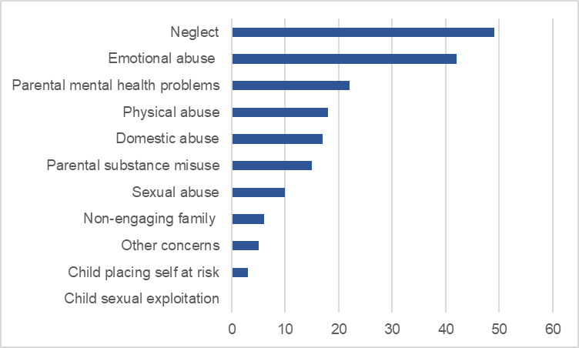
5.11 Child Protection Registrations and De-Registrations

(a) Registrations (Scotland)

During 2021-22, there was a total of 3,286 registrations during the year following an initial, pre-birth, or a transfer-in conference. This is a 5% decrease from 2020-21. The majority of registrations (78%) concerned children who had not been registered before.
Of those registered, 22% of registrations were for children who had been registered before – a slight increase from 20% in 2020-21. Of these, the largest proportion of registrations (11%) were for children de-registered two years ago or more.
Number and percentage of registrations during the year following an initial, pre-birth, or transfer-in Case Conference by length of time since previous de-registration [Note 1]

Time since last de-registration | 2012  Number | 2012 Percentage | 2021 Number | 2021  Percentage | 2022  Number | 2022 Percentage
Never been registered before | 3,408 | 82% | 2,757 | 80% | 2,573 | 78%
Registered before but time unknown | 10 | 0% | 0 | 0% | 0 | 0%
Less than 6 months | 89 | 2% | 77 | 2% | 71 | 2%
6 months to under 1 year | 99 | 2% | 80 | 2% | 114 | 3%
1 year to under 18 months | 83 | 2% | 92 | 3% | 77 | 2%
18 months to under 2 years | 79 | 2% | 66 | 2% | 58 | 2%
2 years or more | 304 | 7% | 363 | 10% | 368 | 11%
Unknown whether child was registered before | 83 | 2% | 24 | 1% | 25 | 1%
Total | 4,155 | 100% | 3,459 | 100% | 3,286 | 100%
[Note 1] Some totals may not exactly equal the sum of their parts due to the effects of rounding.

(b) Registrations (Local)
Number and rate (per 1,000 pop) of registrations during the year following an initial, pre-birth, or transfer-in Case

2016 |  | 2017 |  | 2018 |  | 2019 |  | 2020 |  | 2021 |  | 2022
No. | Rate | No. | Rate | No. | Rate | No. | Rate | No. | Rate | No. | Rate | No. | Rate
273 | 5.0 | 251 | 4.6 | 295 | 5.3 | 220 | 4.0 | 280 | 5.0 | 239 | 4.3 | 225 | 4.0

5.12 De-registrations (Scotland)
If and when the practitioners working with the child and family decide that the risk of significant harm to the child has been sufficiently reduced and the child or young person is no longer in need of a Child Protection Plan, the child may be de-registered from the Register.

During 2021-22, a total of 3,364 children were de-registered from the Register – a 15% decrease since 2020-21. More than half of de-registrations (55%) were due to an improved home situation while 84% of de-registrations were for children on the Child Protection Register for less than one year

- Number and percentage of de-registrations during the year by length of time on Registration and reason for de-registration
Length of time registered and reason for  de-registration | 2012  Number | 2012 % | 2021  Number | 2021 % | 2022  Number | 2022 %
Length of time registered
Less than 6 months | 1,929 | 46% | 1,814 | 46% | 1,655 | 49%
6 months to under 1 year | 1,535 | 37% | 1,395 | 35% | 1,170 | 35%
1 year to under 18 months | 516 | 12% | 444 | 11% | 313 | 9%
18 months to under 2 years | 117 | 3% | 158 | 4% | 111 | 3%
2 years or more | 58 | 1% | 73 | 2% | 75 | 2%
No date of registration information | 0 | 0% | 91 | 2% | 40 | 1%
Reason for de-registration
Child taken into care & risk reduced | 582 | 14% | 404 | 10% | 407 | 12%
Child with other carers | 295 | 7% | 289 | 7% | 197 | 6%
Child died | 9 | 0% | 7 | 0% | 8 | 0%
Removal of perpetrator | 70 | 2% | 141 | 4% | 164 | 5%
Improved home situation | 1,742 | 42% | 2,209 | 56% | 1,841 | 55%
Child automatically de-registered because of age | 6 | 0% | 7 | 0% | 4 | 0%
Child moved away - no continued risk | 20 | 0% | 16 | 0% | 19 | 1%
Other reason | 1,431 | 34% | 902 | 23% | 724 | 22%
Reason not known [Note 2] | 0 | 0% | 0 | 0% | 0 | 0%
Total | 4,155 | 100% | 3,975 | 100% | 3,364 | 100%

[Note 1] Some totals may not exactly equal the sum of their parts due to the effects of rounding.
[Note 2] Includes where a child transferred to another local authority and where reason has not been recorded
- De-Registrations (local)
Length of time registered and reason for de-registration | 2012 | 2012 Percentage | 2021 | 2021 Percentage | 2022 | 2022 Percentage
Length of time registered and reason for de-registration | Number | 2012 Percentage | Number | 2021 Percentage | Number | 2022 Percentage
Length of time registered
Less than 6 months | 99 | 44% | 186 | 67% | 156 | 66%
6 months to under 1 year | 81 | 36% | 71 | 26% | 65 | 27%
1 year to under 18 months | 26 | 12% | 20 | 7% | 12 | 5%
18 months to under 2 years | 17 | 8% | 0 | 0% | 5 | 2%
2 years or more | 1 | 0% | 0 | 0% | 0 | 0%
No date of registration information | 0 | 0% | 0 | 0% | 0 | 0%
Reason for de-registration
Child taken into care & risk reduced | 20 | 9% | 43 | 16% | 31 | 13%
Child with other carers | 0 | 0% | 0 | 0% | 0 | 0%
Child died | 0 | 0% | 0 | 0% | 1 | 0%
Removal of perpetrator | 0 | 0% | 0 | 0% | 0 | 0%
Improved home situation | 192 | 86% | 223 | 81% | 197 | 83%
Child automatically de-registered because of age | 0 | 0% | 0 | 0% | 0 | 0%
Child moved away - no continued risk | 12 | 5% | 11 | 4% | 9 | 4%
Other reason | 0 | 0% | 0 | 0% | 0 | 0%
Reason not known [Note 2] | 0 | 0% | 0 | 0% | 0 | 0%
Total | 224 | 100% | 277 | 100% | 238 | 100%

5.13 The Scottish Children’s Reporter Administration (SCRA)
SCRA produces data per local authority annually.
In table (a) information relates to Children referred and referrals by sex. 743 referrals were received relating to children and young people in South Lanarkshire, of which 459 were progressed by the Reporter for further consideration at a Children’s Hearing.
In table (b) information relates to compulsory supervision orders made or already in place during the specified period. A total of 95 children were placed on a Compulsory Supervision Order (s83, Children’s Hearing (Scotland) Act 2011. A total of 133 had their Order terminated. At the year-end, a total of 383 were subject to compulsion. 34 children were subject to Child Protection Orders.
You can view all the most recent statistics per local authority area for April 2022 – March 2023 here

- Children Referred and referrals received by sex

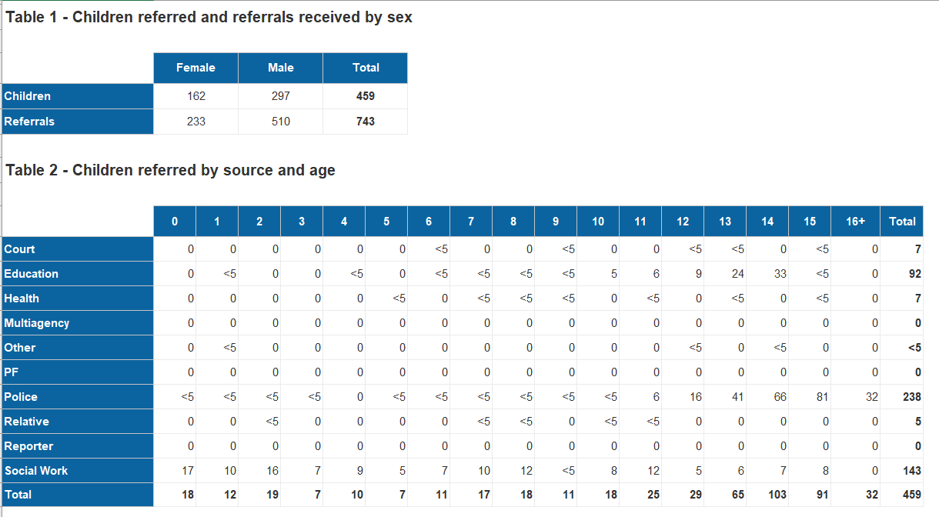

- Children with Compulsory Supervision by age.

NB: Data includes the number of Child Proteciton Orders in the same period.

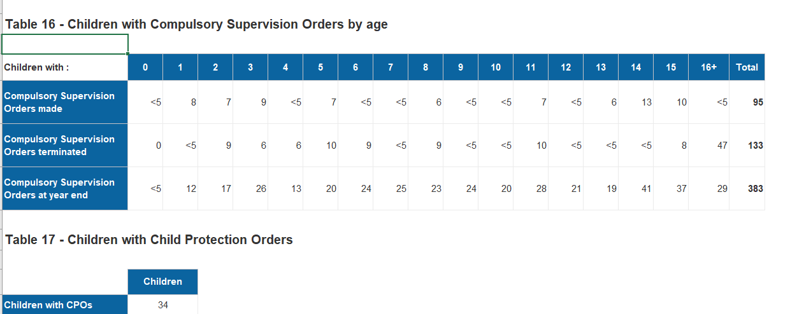

- TRAINING, LEARNING AND STAFF DEVELOPMENT

6.1 Key Functions

One of the key functions of South Lanarkshire Child Protection Committee is to prepare and deliver an extensive programme of multi-agency child protection learning and development opportunities. Training is available to all agencies both statutory and non-statutory in our area who support children, young people, and families. Demand continues to be high using hybrid modelling for delivery.

6.2 SLCPC Learning and Development Programme

The learning and development programme has been revised to reflect current trends, and updated guidance. It offers a range of learning opportunities. Using a national learning and development framework (currently under review) we routinely self-evaluate our training and learning and development opportunities to ensure it meets both local and national standards in getting it right for the child protection workforce and children, young people, and families in South Lanarkshire. We include lessons learned from local and national Learning Reviews and legislative changes as they occur.

Our new training programme plan for the next period linked to our business plan can be accessed via the link below or by emailing the Learning and Development Worker at PublicProtectionOffice@southlanarkshire.gov.uk

Further development opportunities continue to be available in partnership with colleagues across Public Protection and are promoted as available.

- LEADERSHIP, GOVERNANCE & ACCOUNTABILITY
As leaders, the Public Protection Chief Officers Group (PPCOG) agree and provide a clear vision, shared values and aims that promote the protection of all children and young people. The PPCOG’s commitment to the protection of children and young people have been restated by the local authority Chief Executive; and by driving forward improvements in child protection policy and practice to meet the needs of children and young people at risk of harm, abuse, or neglect. The PPCOG demonstrates effective collaborative working to discharge its child protection responsibilities and consistently promotes effective joint working. Supported by the SLCPC Chair and Child Protection Lead Officer, members drive forward an extensive work plan and routinely evaluate its work to ensure there is a clear focus on continuous improvement and accountability, by the application of outcomes measures.
The Child Protection Improvement Programme (CPIP) identified leadership as a “critical factor in creating a system with effective processes and a culture to ensure children are protected from abuse and neglect”. The National Child Protection Leadership Group has been supporting Chief Officers and CPCs strengthen delivery of their responsibilities in a number of ways. The Scottish Government published Protecting Children Young People Child Protection Committee & Chief Officer Responsibilities (Feb 2019) which supports our planning processes. The Public Protection Chief Officers publication Induction Resource was developed in 2021. As a good practice example, it was published by the Scottish Government with the purpose of highlighting legislation, guidance, and policies relevant to public protection in a national context, and to offer specific detail on the role and responsibility of Chief Officers.
Development sessions with the Public Protection Chief Officers Group (PPCOG) are facilitated by the SLCPC & SLASPC Chair, and the lead officers from the public protection team.
The PPCOG has sought to be self-aware and has undertaken self-evaluation exercises to consider the progress made and where improvements are needed. This is supported by a SMART action plan where progress is monitored quarterly at PPCOG meetings. The self-evaluation activities have been framed around honest challenge and we have had the benefit of staff survey evidence related to inspection activity that has helped highlight areas of strength and for further improvement.
Leaders across the partnership make efforts to be visible and to articulate to frontline colleagues to indicate the direction for child protection activities but also through products like the Children’s Services Plan and the South Lanarkshire Child Protection Committee Annual Report & Business Plan, to articulate our approach to early intervention and protection.
Leaders have however been clear in our prioritisation of needs approach that clinical safety and public protection activities will always be prioritised over any other areas of spend and this is reflected in the difficult budgetary decisions that are faced.
In relation to strengths, the partnership relationships are very positive with a clear and evident level of healthy challenge in holding each other to account. There is an absolute commitment to the promotion of public protection and taking a whole system approach to the services that support the most vulnerable residents in our area. There is a considerable range of good practice across the partnership and a continuing commitment to innovative practice.
The SLCPC Chair and Lead Officer meet with the Public Protection Chief Officers Group quarterly to discuss, inform, report, and seek assurance and direction on child protection matters of local and national interest. The priorities for the year ahead can be viewed in the South Lanarkshire Child Protection Committee Business Plan August 2023 – July 2024 as shown in Appendix 1.

Appendix 1

South Lanarkshire Child Protection Committee (SLCPC)

Business Plan 2023 – 2024

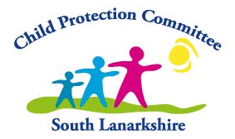

Our Business Plan August 2023 – July 2024 has been developed with reference to our locally identified areas for improvement and includes the outcomes set within the Child Protection Improvement Programme (CPIP) and the quality indicators set out in the recently revised Care Inspectorate Quality Framework for Children and Young People in need of Care and Protection (2022)

The South Lanarkshire Public Protection Chief Officers Group (PPCOG) are responsible for ensuring an Annual Report and Business Plan for the year ahead is published as stated in the National Guidance - Child Protection Committee and Chief Officer Responsibilities (2019) this includes ensuring formal processes are in place to evaluate progress as outlined in our Business Plan (2023-2024). Objectives and areas for improvement that arise from the Annual Report and audits, self- evaluation undertaken are progressed by the SLCPC Quality Assurance and Management Information Sub-Groups as they arise. Learning Reviews improvements are governed by the Strategic Case Review Sub-Group and feed into quality assurance work of the SLCPC and is reported to the PPCOG.

Chief Officers are responsible and accountable for improving the experience of and outcomes for children who may need protection. South Lanarkshire Child Protection Committee (SLCPC) is the multi-agency mechanism to take forward this work.

Our overall aim is to improve the outcome for children & young people. In doing so we place the child at the centre of self-evaluation and look at the impact the work of SLCPC can have on a child’s life and from practice, the positive outcomes as a result.
We know key processes are the essential tasks and actions undertaken by staff in their professional relationship with children and young people which allow for best practice. Our business plan outlines our priorities for the year ahead.
Self-Evaluation in Planning Improvement
Self-evaluation helps us to establish a baseline from which to plan to improve outcomes for children, young people, and families. This supports our collective commitment to set priorities for improvement that can be aligned with local business planning and provide a robust evidence base. Establishing how to make improvements in outcomes for children, young people, and families, and how to measure these, is the central aim of self-evaluation for SLCPC.
The continuing focus for SLCPC is on those areas of concern that have the most negative impact upon children and young people. By using the Care Inspectorate’s Quality Framework of quality indicators, we can work together with partners to:
  - Scrutinise and reflect upon practice and identify strengths and areas for improvement

  - Recognising and celebrate the work partners are doing that has a positive impact on the lives of children, young people, and their families and where there might be gaps

  - Identify where quality needs to be maintained, where improvement is needed and where partners should be working towards achieving excellence

  - Allow partners to inform stakeholders about the quality of services for children, young people, and families.

SLCPC recognise vision is key to planning for improvement and will set out what outcomes measures services hope to achieve to improve the safety, health, wellbeing and life chances of children and young people.

After undertaking any self-evaluation task, the next stage of activity for the SLCPC is making an action plan based on what is required to improve outcomes for children, young people, and families.

Self-evaluation helps us to focus on their areas of expertise and good practice and use the learning to help staff continue to develop services and celebrate success.

We value support at local and national level in getting it right. Our key questions are as follows:

How good are we now?

This is the starting point in our self-evaluation work and is the baseline for any further development and improvement. By using performance management information, intelligence gathered from quality assurance and feedback from children, young people, families and staff, partnerships we will be able to assess, analyse and evaluate how good they are currently. The use of the quality indicators will enable benchmarking of current practice alongside progress against local and national targets for SLCPC. Important enquiry points include:

- How effective are key processes in achieving improved outcomes for children, young people, and their families?
- Are we providing appropriate, accessible, high-quality services, activities, or opportunities?
- Are we setting and achieving ambitious targets?
- Are we systematically improving the quality of what we offer?

Answering these questions should help us identify strengths within and across our child protection work so we can begin to consider areas that need to be improved or further developed.

How do we know?

SLCPC work consistently to gather evidence and develop our auditing processes so we can demonstrate how well the lives of children and young people are improving.

Alongside each of the quality indicators in this Care Inspectorate’s - A quality framework for children and young people in need of care and protection (2022) are potential sources of evidence that assist us carry out the task. We know self-evaluation can only be as reliable as the evidence supporting it.

The key sources of evidence we include are:

  - Performance data collected nationally and locally
  - Feedback from children, young people and families who have experienced services
  - Direct observation and auditing of multi-agency practice
  - Regular review of a range of guidance that evidences decision-making and assessment of risk.
  - Our learning and development opportunities.

SLCPC acknowledge reliable self-evaluation involves benchmarking inputs, outputs, and outcomes with comparator areas. Our self-evaluation is open to scrutiny and how evaluations are determined should are always transparent and credible.

What we plan to do next?

This question helps SLCPC to take forward the learning from the self-evaluation we undertake and assists us to develop a set of clear and tangible priorities for improvement.

We use the evidence we have gathered to support our outcomes and change those that need more development. We use robust evidence to plan for future developments so they best meet the needs of those we work with. This allows identification of the most appropriate course of action to ensure improvement is realistic, achievable, and likely to impact positively upon outcomes for children and young people. WE work to ensure our improvement plans are SMART (Specific, Measurable, Achievable, Realistic and Timely).

Please find our Business Plan focus for the period 2023 – 2024 using the Care Inspectorate Quality Indicators as are our guide below:

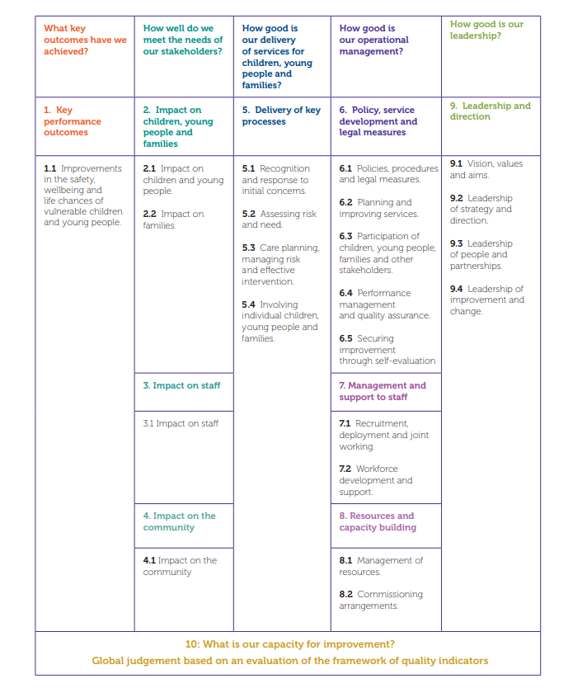
Source: Quality framework for children and young people in need of care and protection NOV 2022.pdf

Quality indicator 1.1- Improvements in the safety, wellbeing and life chances of children and young people in need of care and protection

Key factors for the SLCPC will be the extent to which by working together we are achieving:

- Improvements in the safety and wellbeing of children and young people in need of protection.
- Improvements in the wellbeing of children and young people for whom community planning partners have corporate parenting responsibilities.
- Improvements in the life chances of care experienced young people up to 26 years of age.

We also want to know to what extent can we demonstrate:

- Positive and sustained trends (three years or more) in improving outcomes for children and young people in need of care and protection.
- The effective use of reliable data measures is providing results that demonstrate improving outcomes over time for children in need of care and protection.
- Improved outcomes as a result of carefully gathered and analysed trend data that has been well used to understand cause and effect.
- Key measures that children in need of protection are increasingly safer.
- Action taken based on reports on performance using the Minimum Dataset for Child Protection Committees.
- We have systems and processes in place that produce reliable and robust data gathering and analysis.

QI 1.1 - SLCPC ACTIVITY 2023 – 2024

- Carry out a number of planned continuous improvement activities over a number of identified child protection areas, as described in our self-evaluation programme.
- Consult regularly with the CPC and its Task Groups, reporting findings to the Public Protection Chief Officers Group (Public Protection) ahead of implementing change.
- Conduct agreed multi-agency case file audits to consider practice, processes and the views of children, young people, and families in keeping children safe.
- Review local and national data related to Learning Reviews in achieving sustained change that improves outcomes through system change.
- Review locally, the National Shared Data Set Child Protection with our partners as part of continuous improvement work at local and national level.

Quality indicator 2.1 - Impact on children and young people

Key factors for SLCPC will be a continued focus on:

- The extent to which children and young people feel listened to and that their views are taken seriously when decisions are being made.
- Evidence that children and young people’s wellbeing is improving across all the wellbeing indicators.
- Ensuring children and young people have their rights protected and promoted and they experience no discrimination. Including those with learning or communication difficulties.
- Those who are very young, or whose disabilities mean they cannot easily communicate have their feelings and views considered by careful observation to identify and understand any changes in their health and wellbeing.

QI 2.1 – SLCPC ACIVITY (2023-2024)

We will consider the impact on children and young people and the extent to which children and young people in need of protection have their needs met by:

- Ensuring children and young people feel listened to, understood, and respected by making available the information and opportunities they need.
- Measuring how children and young people feel safe, healthy, achieving, nurtured, active, respected, responsible, and included through routine review of the child’s plan including risk and other assessments. .
- Improving outcomes on the child protection register with the introduction of Advocacy for children subject to child protection.
- Seeking evidence of increased contribution of voice and rights for children and young people attending child protection planning meetings.
- Organising public information events consult with children and young people in our communities on topics such as exploitation and online safety.
- Continued work across public protection to strengthen our joint activities in relation to transitions for young people aged 16-17yrs

Quality Indicator 2.2 - Impact on families

Key factors for SLCPC are:

- The extent to which parents and carers experience greater confidence in parenting and increased resilience.
- Skilled practitioners, in children’s and adult’s services, establish good working relationships with parents and carers.
- Relationships between practitioners and parents/carers are based on honesty about what needs to change and why.
- Parents and carers are supported to build their parenting confidence through access to a range of services.
- Parents and carers work in partnership with staff to develop the flexible support that they each need to build their resilience.
- Parents whose children and young people are looked after away from home feel that their rights are respected. They feel supported by staff and carers to retain involvement in their child’s life.

QI 2.1 – SLCPC ACIVITY (2023-2024)

We will seek evidence that:

- Parents and carers feel that they are listened to and staff take what they say seriously.
- Parents and carers consider that they are kept well informed about what is happening and why.
- Consider that parents and carers are working in partnership with practitioners who know them well and understand their needs.
- Parents and carers are motivated to make important changes in their behaviour using available assessment tools and frameworks.
- We can evidence that in child protection work, parents and carers are much more confident, competent parents who no longer rely on services when they face difficulties.

Quality indicator 3.1: Impact on staff

Key factors for SLCPC include the extent to which staff:

- Participate in multi-agency child protection approaches that improve outcomes
- Feel motivated and experience positive supportive leadership at all levels
- Feel listened to and respected by staff from their own, and other agencies
- Can demonstrate professional competence and confidence in practice
- Feel that their work contributes to improved outcomes for children and young people
- Staff routinely benefit from support and high-quality reflective supervision
- Staff are motivated to improve their practice through learning and development

QI 3.1 – SLCPC ACIVITY (2023-2024)

We will demonstrate the extent to which the child protection workforce participates in multi-agency approaches to improve outcomes for children and young people by:

- Ensuring staff experience consistent levels of consultation that informs practice and helps staff feel listened to.
- Ensuring practitioners and mangers across the multi-agency workforce are aware of, and know how to refer to the SLCPC Communications & Media Strategy
- Demonstrating confidence and competence in practice supported by high quality learning and development opportunities to meet their needs, through routine evaluation of learning opportunities,
- Showing high levels of motivation to work together to achieve the best possible outcomes for children and young people.
- Demonstrating high levels of confidence in their contingency plans, chronologies, risk assessments and agreed SMART Outcomes.
- Routinely receive support and benefit from high quality reflective supervision.
- Have a shared understanding of the needs of children and young people subject to child protection.

Quality indicator 4.1: Impact on the community

Key factor for SLCPC include the extent to which:

- Communities are confident in public services available to support families and protect children and young people in need of care and protection.
- The views of communities are sought, heard, and taken on board to inform policies, planning and service development.
- A range of approaches and mechanisms are available to support community engagement. For example, digital, written, and verbal communication, including access to translation, and specialist communications tools.
- Communities have an awareness and confidence in their public role to protect children from harm, neglect, abuse, bullying and exploitation.
- The views of communities are reflected in policies, procedures, and strategic documentation.
- Communities demonstrate their awareness of their role in protecting children and young people.

QI 4.1 – SLCPC ACIVITY (2023-2024)

SLCPC will consider impact on the community and promote confidence in public services available to support families and protect children and young people by:

- Enhancing our website to ensure the most up to date information is available for those concerned about a child or have a child in the child protection system. Including information on social media platforms for children and young people.

- Widely circulating information in a number of different ways including a number of social media platforms, and printed information readily available in public places such as local council offices, health centres, hospitals, police stations, voluntary organisations, leisure services and education environments, as appropriate.

- Displaying information created by children and young people in our communities about “Keeping Safe in South Lanarkshire”.

- Ensure Members of the public are alert to signs of risk and harm to children and young people and are confident in sharing their concerns with services.

- Members of the public have a high degree of awareness about how to report concerns and are confident that children and young people will get the help that they need as a result.

- Children, young people, and families feel safe, supported, and cared for in the community. They live in increasingly safer communities and young people are viewed positively.

Quality indicator 5.1: Recognition and Response to Initial Concerns

Key factors for SLCPC are the extent to which effective processes are in place to:

- Recognise and respond promptly to concerns about a child or young person’s safety or wellbeing.
- Enable initial information gathering and investigation.
- Ensure appropriate consideration of legal measures.
- Support timely decision making about children and young people who need additional support or protection.
- Ensure systems are in place for receiving and recording information from anybody who is concerned about the safety or wellbeing of a child (including outside office hours).
- Ce clear that staff, including those who work with adults, are alert to and recognise the signs that children and young people may need help or protection from harm. This includes patterns of concern over time and cumulative harm.
- If a concern is raised about a child or young person that requires further exploration, staff have the skills to gather relevant information, know what the other sources of information are and how to get them.
- Staff confidently analyse the information gathered to reach an initial assessment.
- Appropriate consideration is always given to arranging inter-agency referral discussions (IRDs) involving, as a minimum, police, health, and social work.
- Inter-agency referral discussions (IRDs) always take place in response to child protection concerns including when new concerns arise for children or young people already receiving a service.
- Early referral to the Children’s Reporter for consideration of grounds is always considered and reflect the GIRFEC principles in doing so.

QI 5.1 – SLCPC ACIVITY (2023-2024)

We will consider the extent to which effective processes are in place to recognise and respond promptly to concerns about a child or young person’s safety or wellbeing and ensure we are confident that:

- Staff recognise signs that a child may be at risk of harm, abuse or neglect and report any concerns promptly and appropriately. This includes concerns of risk to an unborn baby.
- Are alert to signs of harm, abuse and neglect includes self-harm and forms of exploitation.
- Staff recognise signs that a child or young person may present a risk to others and share concerns promptly and appropriately, clearly identifying what the concerns and risks are in accordance with national guidance where applicable, such as Care and Risk Management (CARM)
- All staff receiving these concerns respond without delay, whether concerns are made within or outside office hours. They gather information from all relevant sources to make an initial assessment of risk
- Staff share information with others as needed to agree how to ensure public safety and the safety of the child or young person.
- IRDs, involve, as a minimum, police, health, and social work and include education/ELC and other services working together to ensure child safety as appropriate.
- IRDs ensure that all relevant information is available and address all priority considerations.
- IRDs ensure that all of the child’s needs are properly considered and appropriate decisions taken about subsequent actions.
- Staff are sufficiently trained, skilled, and supported to make appropriate decisions on how to proceed, based on all the available information.
- Investigations are planned and conducted effectively by staff with appropriate skills and training including the JII / SCIM model where applicable.

Quality indicator 5.2: Assessing risk and need

Key factors – the extent to which effective processes are in place to:

- Ensure purposeful risk assessments are completed within appropriate timescales.
- Enable thorough wellbeing / risk assessments.
- To support staff to understand the nature and assessment of risk and make sound judgements.
- Create an environment where staff have a good understanding of their need to finely balance risk and need.
- Deliver assessments based on up-to-date, recognised frameworks such as the national practice model and the risk assessment framework.
- Check that chronologies are used to identify patterns of significant events or experiences and routinely shared with partners.
- Be assured any assessments are used effectively to make informed judgements about the risk to and needs of each child or young person. This includes assessment of parental capability and capacity to change.
- Ensure assessments are kept up to date in response to any significant changes.

QI 5.1 – SLCPC ACIVITY (2023-2024)

The SLCPC will continue to regularly review and audit child protection case records including scrutiny of risk assessment and other key processes as noted:

- When reviewing records, we will seek to find if most child protection assessments are evaluated as good or better.
- Assessments consistently contain full, concise, relevant, and accurate information and include a chronology of family and social history.
- Assessment include analysis that makes clear links between the recorded information and plans for intervention or decisions to take further action.
- Chronologies are regularly reviewed and analysed to identify concerns, or an accumulation of experiences, that may adversely affect the child or young person.
- Staff consistently use clear risk assessment methods.
- Managers regularly scrutinise assessments of risk and need and review procedures and protocols and learning and development needs as a result of this.
- Consider the development of an accountability framework for managers in ensuring consistent quality of reports and other key recordings.

Quality indicator 5.3: Care planning, managing risk and effective intervention

Key factors for SLCPC in effective intervention and risk management are:

- Examining the extent to which effective processes are in place to support practice
- Evidencing developing plans to meet needs and reduce risk.
- Reviewing progress, joint planning, and decision-making.
- Providing timely and effective intervention to reduce risk, meet need and improve wellbeing.
- Securing stable and caring environments for children and young people.
- Enabling care experienced young people to succeed in their transition to greater independence and adulthood at a time that is right for them.
- Ensuring Comprehensive assessments are well used to develop plans that reduce risk and meet needs.
- Carefully compiling chronologies of significant events that are supporting effective risk management.
- Confident that Care and risk management plans are reviewed at appropriate intervals.
- Able to evidence children and young people receive help that is proportionate to risk and need.

QI 5.3 – SLCPC ACIVITY (2023-2024)

SLCPC will continue to work with partners to ensure:
- The child or young person’s voice is always heard and acted on appropriately to the circumstances, in all planning processes.
- Plans are of a consistently high quality and there is an individual and unique plan for every child in a family.
- Plans are carefully linked to assessments of risk and need.
- Staff have a very clear focus on risk of significant harm as central to effective management of risk and this is evident in the quality of the plans.
- There are clear goals and outcomes for the intervention provided.
- Meetings and decisions are recorded appropriately and the record made available to all relevant staff.
- Meetings and decisions are recorded appropriately and the record made available to all relevant staff. This ensures that they are well informed about progress and any significant changes.
- We will further develop our work in relation to transitions with our colleagues in adult protection for young people (16-17yrs)

Quality indicator 5.4: Involving individual children, young people, and families

SLCPC will continue to work with partners to consider the extent to which:

- The views, wishes and expectations of children, young people and families are sought, listened to, and taken into account.
- Children, young people, and families participate in the key processes.
- Information sharing procedures are in place.
- All children, young people and families’ views are recorded and taken into account in their assessments, plans and decision making.
- Information that is provided about services is helpful and transparent.
- Children, young people, and families know what information is held about them and understand that some information will need to be shared without their consent if it concerns safety.
- Children and young people are offered independent advocacy and / or any supports that they need to fully participate in processes about their lives.

QI 5.4 – SLCPC ACIVITY (2023-2024)

SLCPC will continue to work together to ensure:

- Staff across the partnership listen carefully to children, young people and families and have a thorough understanding of their views, wishes and expectations in line with health and social care standards.
- Feedback on outcomes of decisionmaking about the lives of children and young people are appropriately communicated to the child, young person, and their family.
- We provide helpful information about services that is transparent and easy to understand.
- Partners make available an information-sharing protocol / guidance / briefings that are promoted by staff and easy to understand.
- The views of children, young people and families are recorded and are taken into account in assessments.
- Regular updates on the views and expectations of children, young people, and families.
- Children, young people, and families are treated fairly and inclusively with a respect for difference.
- Information is shared by consent and is managed and recorded to reflect discussions that have taken place to explain this and any exceptions.
- Services act on information received from children, young people, and families to improve their individual experiences and experiences for others.

Quality Indicator 6.1 – Policy, Service Development & Legal Measures

Key factors will include the extent to which:

- Shared policies across public protection reflect the vision, values and aims of the partnership, making them visible in day-to-day practice.
- Policies and procedures reflect national standards and guidance.
- Through evaluation and data collection, we know that legal measures to protect children and young people, keep them safe and secure their future are appropriately considered and promptly pursued.

QI 6.1 – SLCPC ACIVITY (2023-2024)

SLCPC will continue to work together to ensure:

- Policies and procedures are consistent with the strategic vision of the South Lanarkshire Child Protection Committee.
- A comprehensive suite of multi-agency guidance that reflect recent national changes to the child protection landscape are in place to ensure we have no significant gaps.
- SLCPC Policies and procedures reflect a focus on outcomes and sit within accountability frameworks.
- Effective communication and management systems are in place to ensure that employees understand and implement policies and procedures.
- Best practice is promoted through the development of new policies and procedures.
- Our guidance and procedures include the implementation of revised GIRFEC processes.
- Through learning and development, and current multi-agency communication processes; and with the support of SLCPC partners, achieves a high level of compliance with implementation of new procedures and ensures that all partners are informed of any changes or updates.

Quality Indicator 6.2 - Planning and Improving Services

Key factors – the extent to which:

- Planning arrangements, including child protection committee business planning and corporate parenting planning, are leading to improved outcomes for children, young people and care experienced young people.
- Plans reflect the partnership’s strategic priorities for child protection and corporate parenting and commitment to a rights-based approach.
- SLCPC and its partners manage and mitigate emerging or potential risks to children and young people.
- Effective mechanisms are in place for developing, implementing, reviewing, and evaluating strategic and operational plans.
- Governance and reporting arrangements are clear and reflect local partnership arrangements.
- Our plans are informed by a strategic assessment of need, comprehensive data, and performance information.
- Plans are fully reflective of the rights of children and young people.
- Plans are informed by consultation with the public, children, young people, and families who use services, and staff and reflect principles of participation and inclusion.
- Plans lead to tangible improvement in the lives of children, young people and care experienced young people.

QI 6.2 – SLCPC ACIVITY (2023-2024)

SLCPC will continue to work together to ensure:

- We take account of the GIRFEC principles and the Health and Social Care Standards when developing plans.
- Our plans specify SMART objectives and measurable success criteria, based on a manageable number of key priorities.
- The SLCPC has in place clear lines of accountability to ensure that actions are achieved and progress is reported publicly.
- SLCPC demonstrates effective joint working to improve services to children and young people in need of care and protection.
- SLCPC has in place robust systems for monitoring performance and measuring improvement, as well as for regular reporting of progress to strategic groups.
- SLCPC adheres to national guidance and legislative requirements.

Quality Indicator 6.3 – Participation of children, young people, families and other stakeholders.

Key factors include ensuring:

- The rights of children and young people are promoted and respected.
- Consultation with children, young people and families is effective
- Children and Young people subject to child protection processes know how they can share their views and the methods in which they can do so are easy to locate and use.
- Communication methods and our sue of information technology are appropriate to stakeholder’s needs.
- Communication with children and young people, families and stakeholders enable their participation and engagement.
- Children’s and young people’s rights are promoted by SLCPC
- Complaints are used to inform areas for service improvement

QI 6.3 – SLCPC ACIVITY (2023-2024)

SLCPC will continue to work together to ensure:

- SLCPC engages in a meaningful way with a range of stakeholders to ensure that they are active participants in all aspects of children’s services planning.
- That the voice of children, young people and families comes across strongly in all policy making and planning processes.
- SLCPC works with partners to develop creative approaches to engage children, young people to help them inform and influence the way that can be used positively to shape policies and inform plans.
- We can demonstrate how the views of children and young people have influenced policies and future developments.
- That children’s rights underpin our work
- Works with partners to ensure that children, young people, and families know and understand their rights, and are helped to exercise these.

Quality Indicator 6.4 – Performance Management and Quality Assurance

Key factors for SLCPC include evidence that:

- Performance management and quality assurance practices ensure high standards of service delivery and improved outcomes for children and young people in need of care and protection.
- Quality assurance arrangements enable staff at every level to take responsibility for the quality of their work.
- Best practice is routinely identified and celebrated and inconsistent practice is identified and addressed. Learning is identified from both.
- Performance measures, outcome indicators and standards are established and regularly reviewed.
- National CP Minimum Data Set management information is reported, monitored, and reviewed.
- Improvement targets are used against national, local, and virtual comparators.
- Targets are reviewed regularly and used to monitor trends over time.
- Performance management systems are well established and used to inform service delivery and workforce requirements.
- Management information informs quality assurance and self-evaluation activities
- Key processes are routinely quality assured and the findings are communicated with staff.
- Practice management and supervision is informed by the learning from activities such as quality assurance, audits, and Learning Reviews

QI 6.4 – SLCPC ACIVITY (2023-2024)

SLCPC will continue to work together to ensure:

- SLCPC has as an up-to-date performance framework with an agreed set of standards and outcome indicators.
- Progress is overseen by accountable senior leaders and elected members who provide appropriate levels of scrutiny and challenge.
- Analyses data from a range of sources and uses this effectively to inform planning for the SLCPC and its partners.
- Routinely reports on the quality of services for children and young people in need of care and protection.
- Uses performance information and quality assurance approaches to continually strive to improve the quality of work and improve outcomes for children and young people in need of care and protection.
- Supports operational managers and staff to make effective use of performance data to support continuous improvement.
- Creates a safe learning culture that is enquiring and aspirational and based on performance and self-evaluation.
- Regularly communicates to staff expectations and aspirations to deliver services of the highest quality in child protection.

Quality Indicator 6.5 – Securing Improvement through Self-Evaluation

Key factors – the extent to which:

- Self-evaluation Is prioritised, planned and co-ordinated by SLCPC.
- SLCPC chows a commitment to delivering excellence in services for children and their families in need of care and protection.
- The programme of self-evaluation is in place is developed and delivered jointly agreed by partners.
- Self-evaluation priorities link to the local quality improvement framework and identified priorities in the children’s services plan.
- Performance information and quality assurance information is used to inform self-evaluation activity.
- Improved outcomes as a result of self-evaluation activity.
- SLCPC analyse evidence from a range of sources to support findings of self-evaluation.
QI 6.5 – SLCPC ACIVITY (2023-2024)

SLCPC will continue to work together to ensure:

- Aims to deliver excellence in services for children, young people’ and their families in need of care and protection.
- SLCPC has a shared approach to self-evaluation and improvement, underpinned by relevant frameworks
- Uses accurate performance information to identify and agree key priority areas for self-evaluation.
- Carefully plans and co-ordinates a cycle of single agency and joint self-evaluation based on a manageable number of priorities.
- Gathers robust evidence by comparing findings from a number of different activities.
- Supports and encourages staff to carry out self-evaluation as an integral part of their work, equipping them with the knowledge and skills to do this well.
- Works with partners to gather views and information about the experiences of children, young people, and families to inform self-evaluation.
- Self-evaluation focuses on outcomes and can demonstrate notable and tangible improvements in performance and the protection and wellbeing of children, young people, and families.
- Communicates clear improvement priorities so that staff understand fully what they need to do to improve the quality of their work.

Quality indicator 9.1: Vision, values and aims

Key factors for SLPC include the extent to which:

- Partners share a coherent vision to achieve the best possible outcomes for children and young people in need of care and protection.
- Partners ensure that children, young people, families, and other stakeholders have been involved in developing the vision, values and aims.
- Equality and inclusion are promoted. To what extent can we demonstrate:
- Partners place improving outcomes for people using services at the heart of their vision.
- There is a shared vision and sense of purpose for protecting children that is ambitious and challenging.
- Leaders demonstrate collective ownership of the ambitions and aspirations of the partnership.
- SLCPC child protection committee report and business plan reflect leadership and direction.
- SLCPC works with partners to ensure senior managers communication regularly with the workforce about professional standards or expectations.
- Has examples of how senior managers have communicated their vision for children and young people in need of care and protection.
- Employee surveys that demonstrate employees understand the vision.
- Feedback from engagement with children, young people, families, staff, and community members.

QI 6.5 – SLCPC ACIVITY (2023-2024)

SLCPC will work together to ensure aims include:

- SLCPC vision, values and aims in relation to protecting children are shared and clearly stated.
- Leaders promote an open learning culture in which staff feel safe to challenge and are supported to raise serious concerns through whistleblowing or other procedures.
- Leaders ensure that children, young people, families, and other stakeholders are fully involved in developing the vision and shaping the values of partners.
- Partners have a strong collective ownership of ambitions and aspirations.
- Partners regularly re-visit and take action to reinforce their vision, values and aims.
- The work of the partnership is underpinned by a common purpose, shared values, and high expectations.

Key SLCPC Contacts:

SLCPC Independent Chair : Safaa Baxter
Lead Officer Child Protection: Caren McLean

Email: PublicProtectionOffice@southlanarkshire.gov.uk

National Guidance for Child Protection in Scotland (2021) - Updated 2023
Protecting Children and Young People - CPC & COG Guidance (2019)
A Quality Framework for Children and Young People in Need of Care and Protection (2022)
Minimum Data Set for Child Protection in Scotland
UNCRC - Article 12
Getting it Right for Every Child (GIRFEC)
National Learning Review Guidance for CPCs (2021)
Public Protection Learning and Development Programme (2023)
Getting it Right for Every Child (GIRFEC)
National Risk Framework to Support the Assessment of Children & Young People (2012)
National Guidance for Child Protection in Scotland (2021) - Updated 2023
A Quality Framework for Children and Young People in Need of Care and Protection (Nov 2022)
National Learning Review Guidance for CPCs (2021)
National Social Work Statistics 2021-2022
Child Protection Training Programme (2023 - 2024)
Protecting children and young people: Child Protection Committee and Chief Officer responsibilities
A Quality Framework for Children and Young People in Need of Care and Protection (Nov 2022)
A Quality Framework for Children and Young People in Need of Care and Protection (Nov 2022)

